

**CLASS PROJECT 3**

**INTRODUCTION TO BIGDATA AND ANALYTICS**

**By**

**Nikhil Dugyala(G25443567)**

**Rashi Tiwary (G44119910)**

In this project we will be implementing the text analytics to the dataset A Princess of Mars by Edgar Rice Burroughs for the first XI chapters. We will apply various methods from some of the text analytics packages in R to extract data and information from text.

We have used the below packages to implement the project:

* tm: A framework for text mining in R. It provides a set of functions for preprocessing and cleaning textual data, and for creating document-term matrices.
* dplyr: A package for data manipulation and transformation, providing a set of functions for filtering, selecting, and grouping data in a concise and consistent way.
* tidyr: A package for tidying data, which involves reshaping data sets to make them easier to work with. It provides functions for pivoting, gathering, and spreading data.
* tidytext: A package for text mining and natural language processing using the tidy data framework. It provides a set of functions for converting raw text data into a tidy data format and for performing text analysis tasks such as sentiment analysis, word frequency analysis, and topic modeling.
* ggplot2: A popular package for data visualization in R. It provides a grammar of graphics that allows you to create complex and aesthetically pleasing visualizations with a few lines of code.
* wordcloud: A package for creating word clouds, which are a popular way of visualizing the most frequent words in a text corpus.
* quanteda: A package for quantitative text analysis in R, which provides a set of functions for text preprocessing, tokenization, and frequency analysis.
* syuzhet: A package for sentiment analysis in R, which provides a set of functions for extracting sentiment from text using different sentiment dictionaries.
* stringr: A package for working with strings in R, providing a set of functions for manipulating and modifying character strings.
* readr: A package for reading and writing tabular data in R. It provides a set of functions for importing and exporting data in a variety of formats.
* quanteda.textstats: An extension package for the quanteda package, providing additional functions for text analysis and statistics, including text scaling and word correlation analysis.

**SETTING UP THE WORKING DIRECTORY**

First, we have installed the above packages and loaded them as the libraries. We have set the working using the setwd().function. It then reads the text file "APrincessOfMars.txt" using the readLines() function and stores each line of the book as an element in the book_lines object.

Next, a new directory called "chapters" is created using the dir.create() function. This directory will be used to store individual chapter files that will be created later in the code.

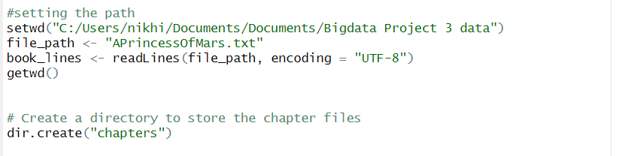

**EXTRACTING THE CHAPTERS FROM DATASET:**

The dataset used for this project is a large document with 11 chapters in total. The chapters for this document is identified using the Roman numbering system, “I”, “II”. Since the text document contains multiple chapters, we create a dictionary to store the chapters. This was achieved using the “which” function in R. Once the chapter is segregated, we will load all the chapters in text file to the VCorpus. Figure 1 shows the code to extracts the text for each chapter of the book from the original text file and saves each chapter as a separate text file.

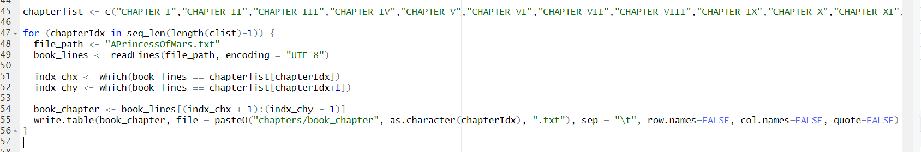

Figure 1

**Creating VCorpus:**

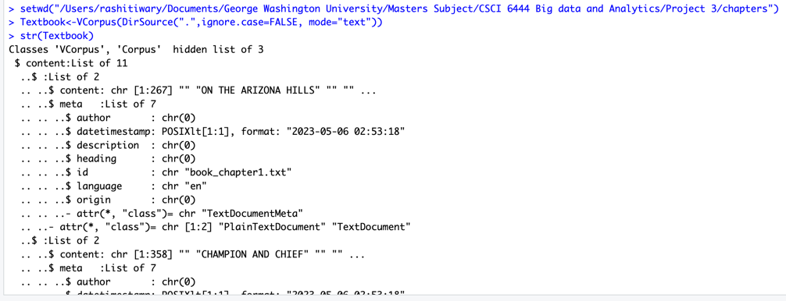To create VCorpus, we parse through the directory of the chapters we had created.

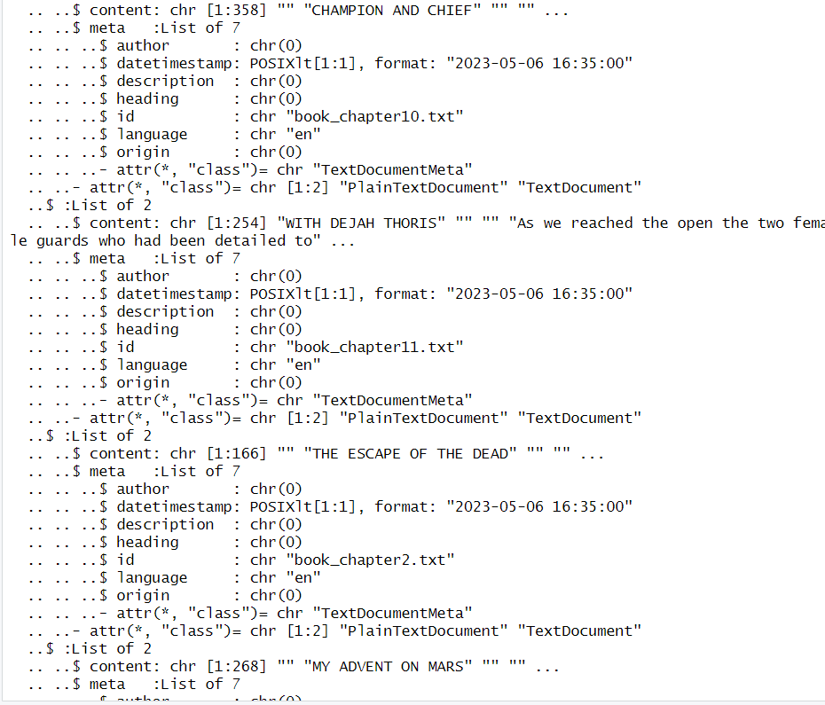

Figure 2

The VCorpus gives information about the text file it has parsed through using the id attribute and the content in the file as well. We can also extract the text and number of characters from the corpus as shown in the Figure 3 and 4.

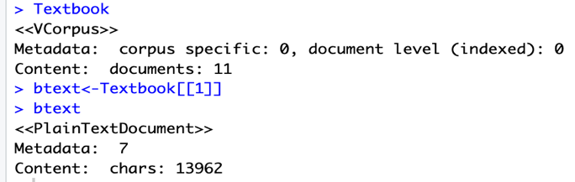

Figure 3

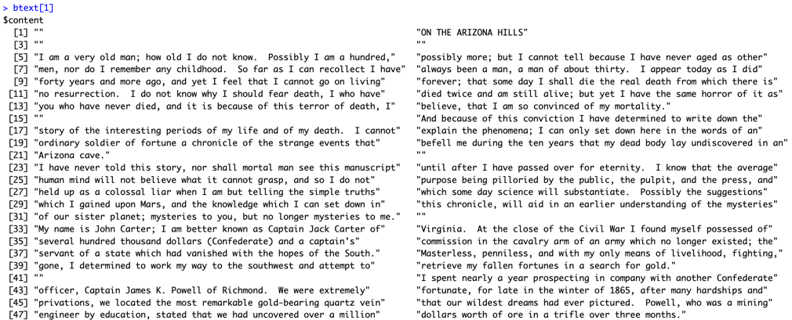

Figure 4

The inspect() function is often used in natural language processing to view the structure and content of text data. This is the output of the inspect() function applied to the Textbook object, which is a corpus of 11 documents. The output shows the metadata and content of each document in the corpus. Each document is represented as a PlainTextDocument object, with metadata information (in this case, metadata level 7) and a character count of the document content.

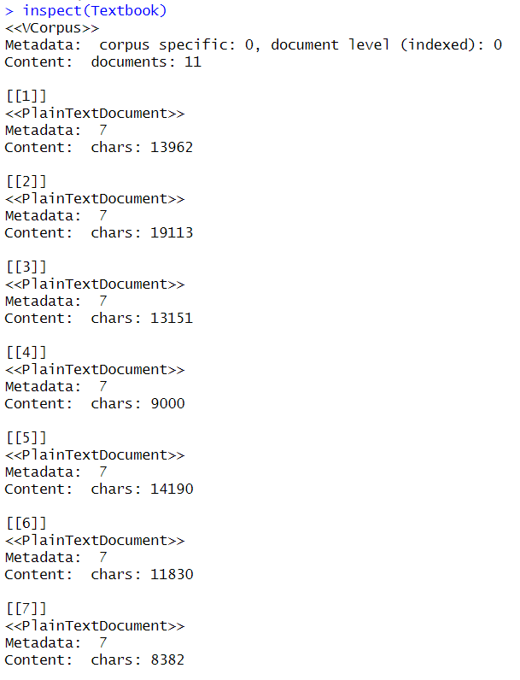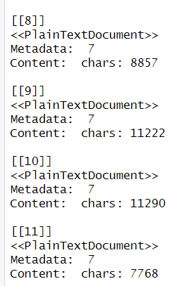

**Finding 10 longest Words and Sentences from each chapter:**

Before removing the stop words and cleansing the data, we identified 10 longest sentences and 10 longest words in each chapter. This is shown in Figure 5, the same has been implemented for all the chapters.

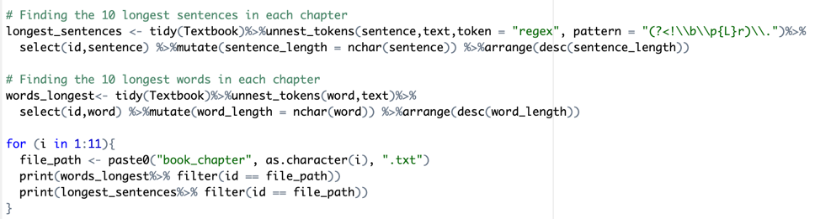

Figure 5

Chapter 1:

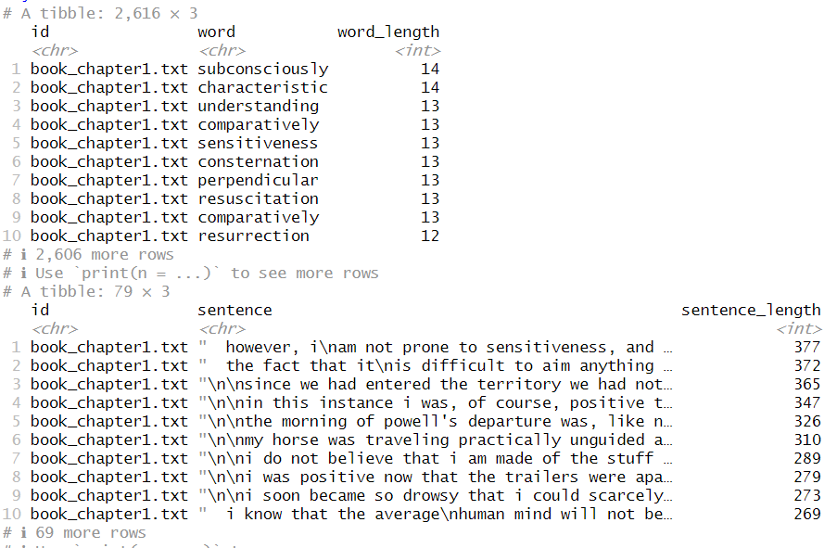

Chapter 2:

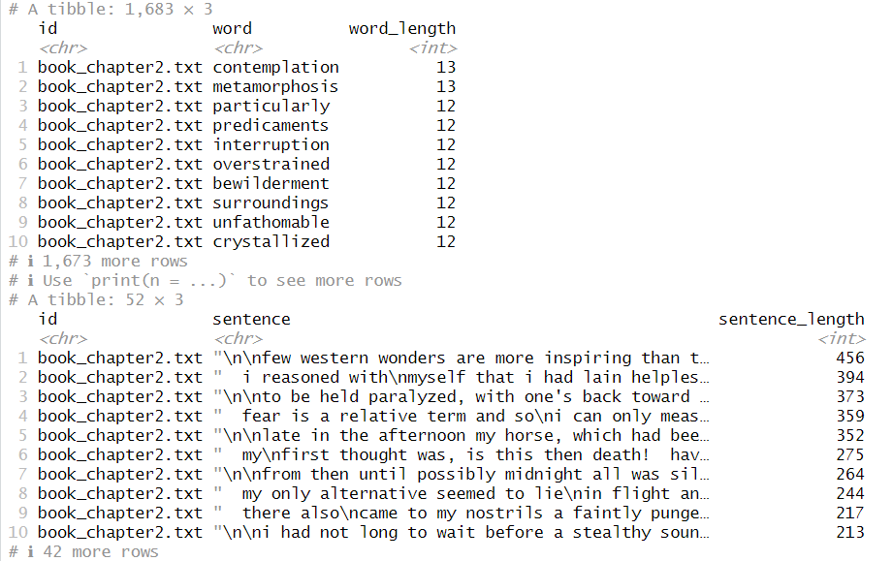

Chapter 3:

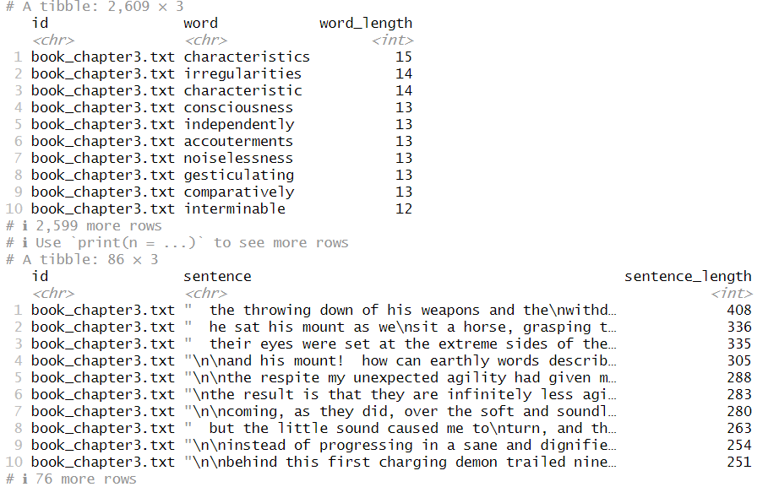

Chapter 4:

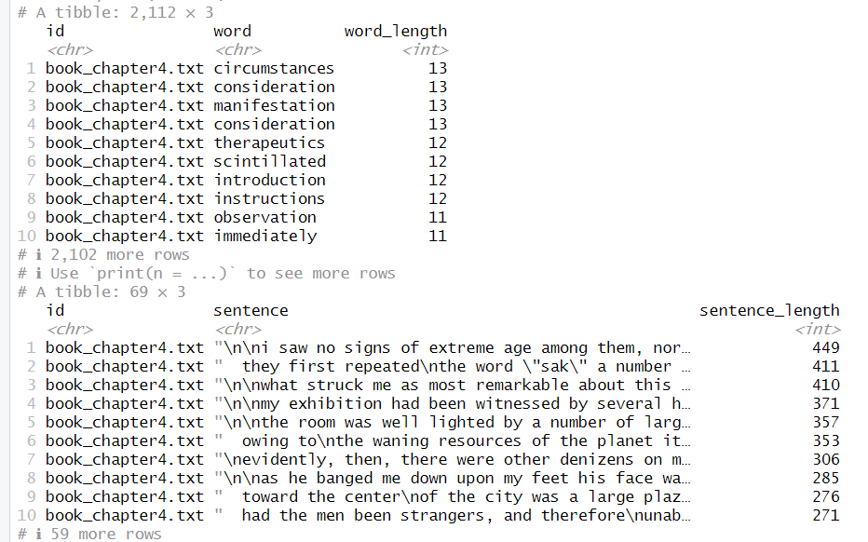

Chapter 5:

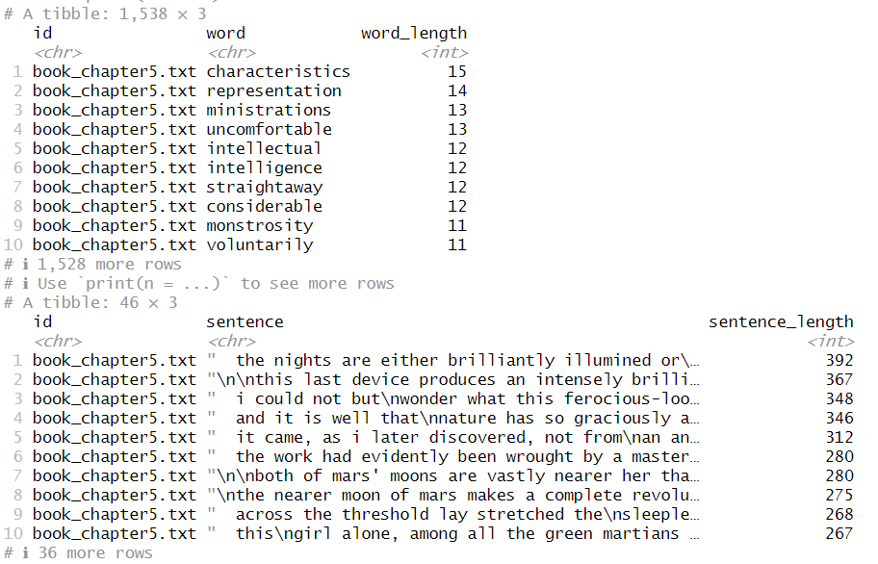

Chapter 6:

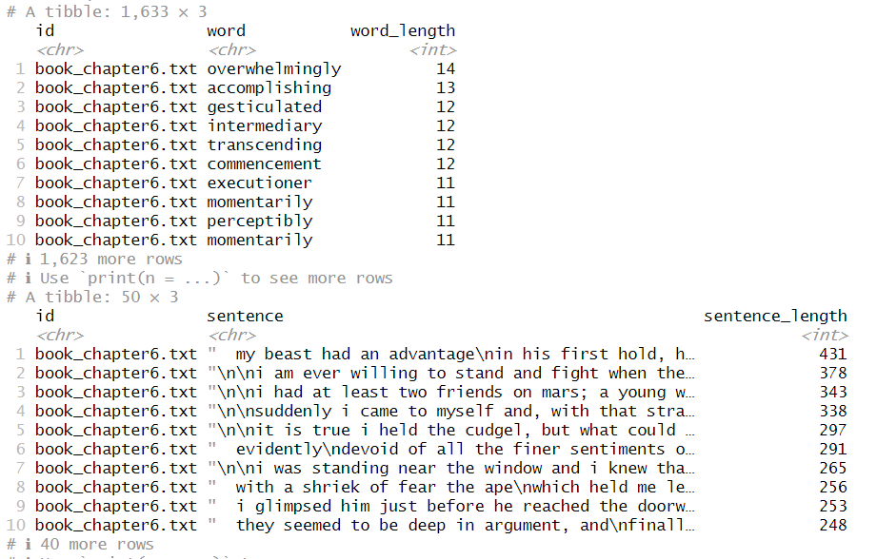

Chapter 7:

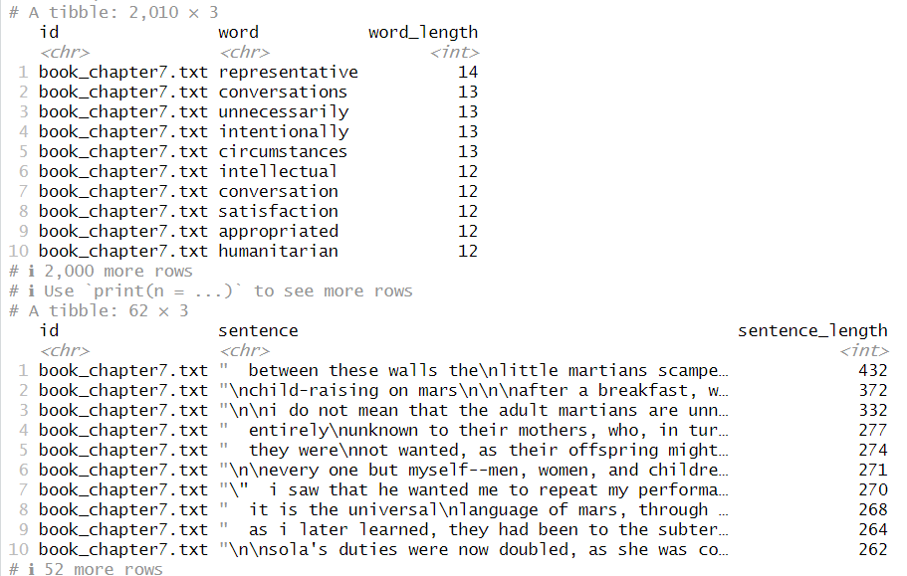

Chapter 8:

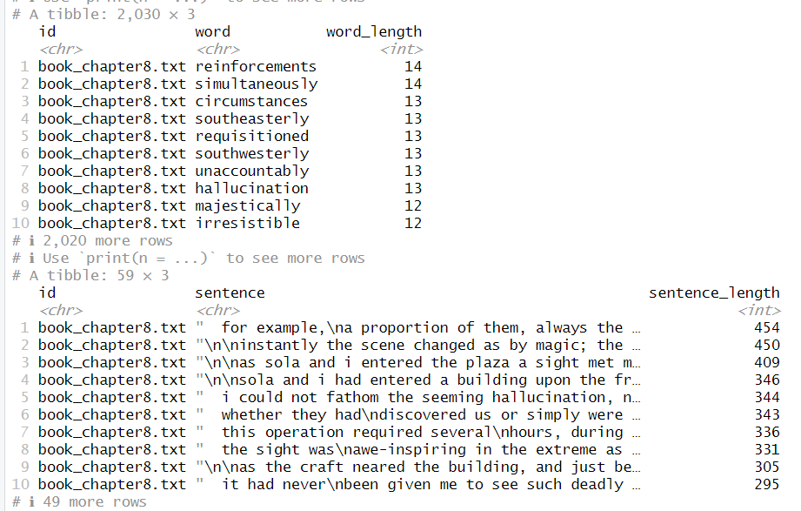

Chapter 9:

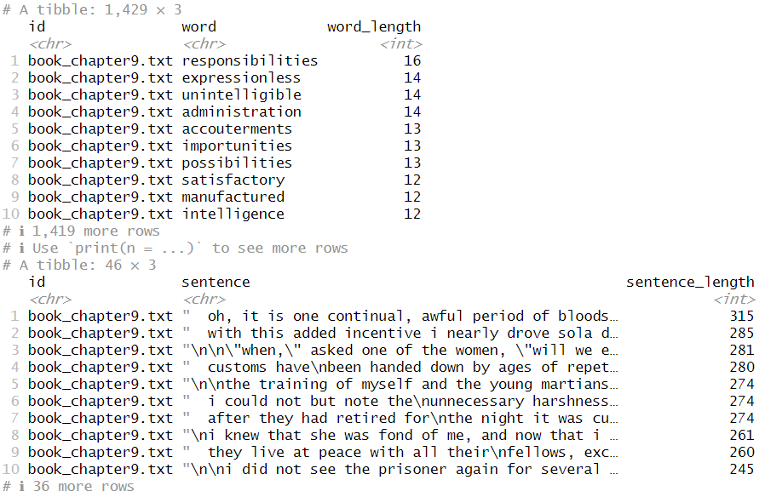

Chapter 10:

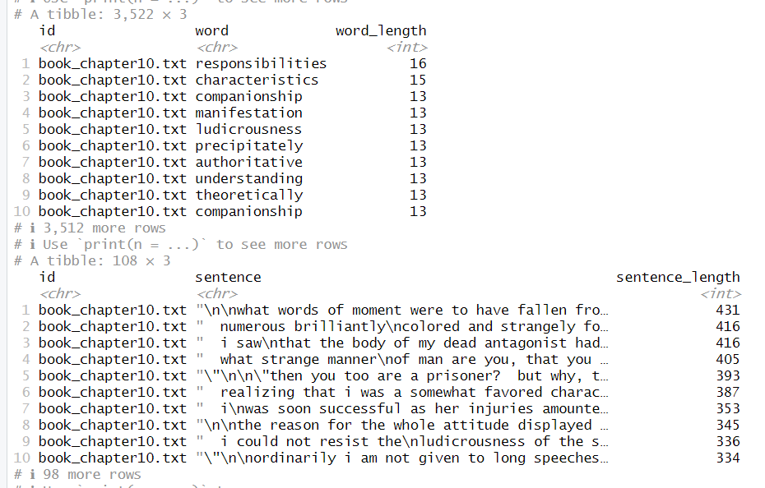

Chapter 11:

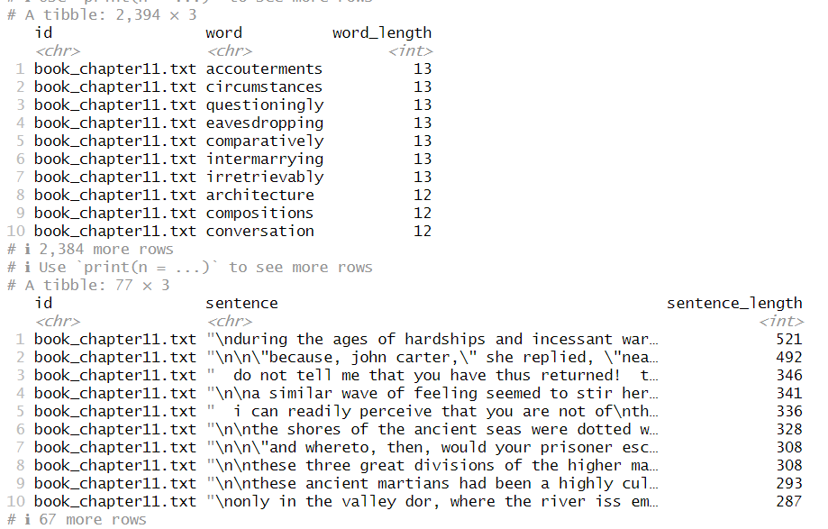

**Document Term Matrix:**

DTM is mathematical representation of corpus where row is the document and columns are the words present in the corpus. We can see that the sparsity is about 83% which is quite common for the text data. Str() function has attribute “nrow” which shows the number of documents in the current directory.

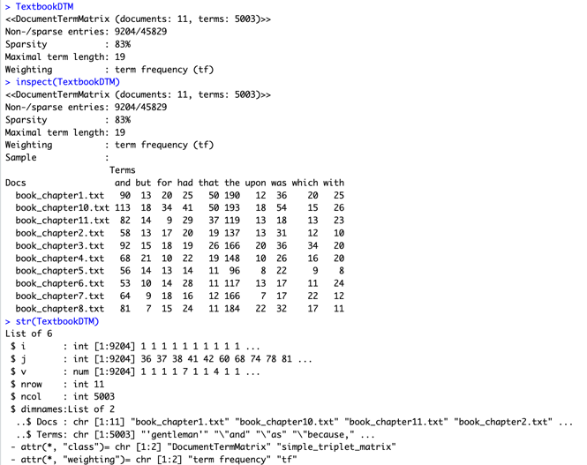

Figure 8

**Term document matrix (TDM):**

The TermDocumentMatrix is a common way to represent text data in Natural Language Processing (NLP). It is a matrix that shows the frequency of terms (words, phrases, etc.) in a corpus of documents.

In a TermDocumentMatrix, each row represents a term and each column represents a document in the corpus. The cells in the matrix contain the frequency of each term in each document.

The inspect function is used to print the contents of the TermDocumentMatrix in a human-readable format, so you can see the frequency of terms in each document. The str function shows you the structure of the TextbookTDM object, including the number of terms and documents, as well as some other information about the matrix.

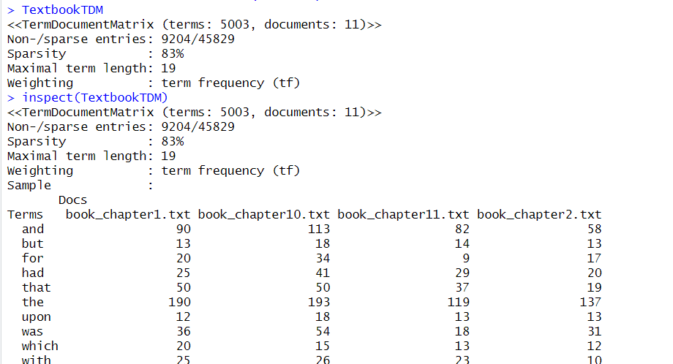

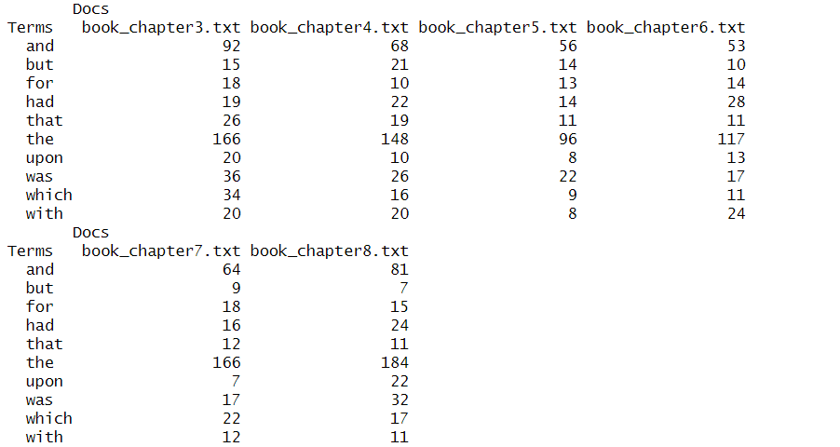

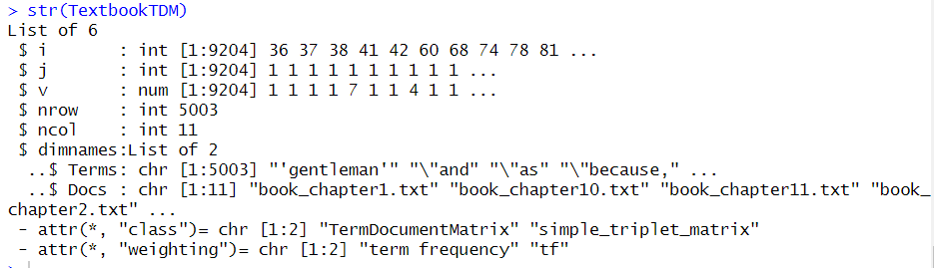

Figure 9

**Creating a Data frame:**

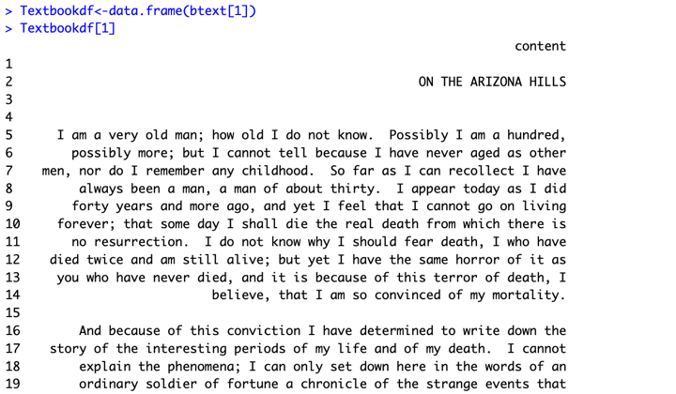

Figure 10

We can see that as compared to “btext” in Figure 4, the content is better aligned and separated in the Figure 10. We can see paragraph separated content of the story once we converted it into dataframe.

**Removing numbers and punctuation:**

Before performing more analysis, we will do some more cleansing of our data by removing punctuations and numbers. The number of characters goes down significantly once these are removed.

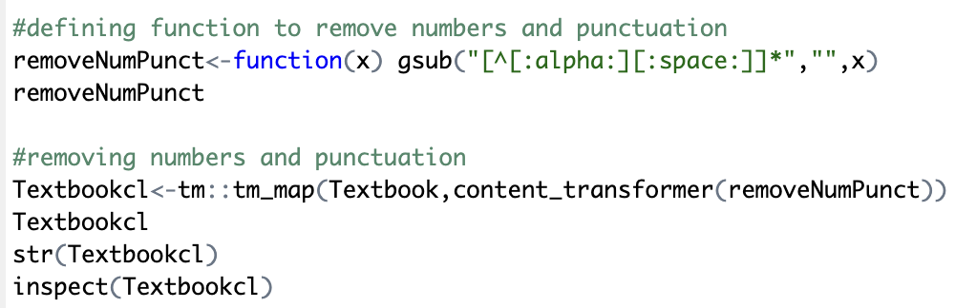

Figure 11

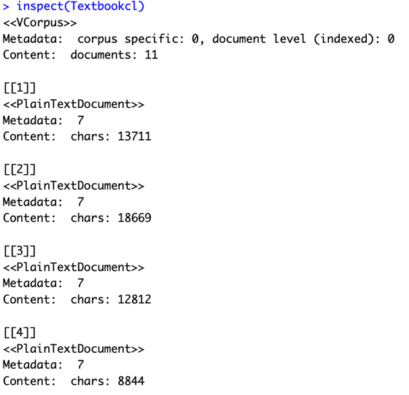

Figure 12

We had also converted the document into lowercase.

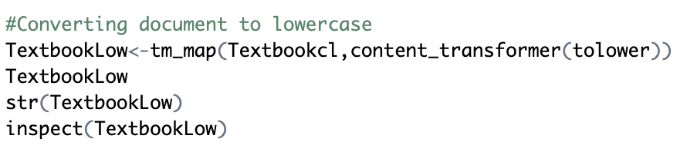

Figure 13

We will compute DTM once again to check the sparsity of our data. We can see that there has been a slight decrease in the sparsity value for our DTM.

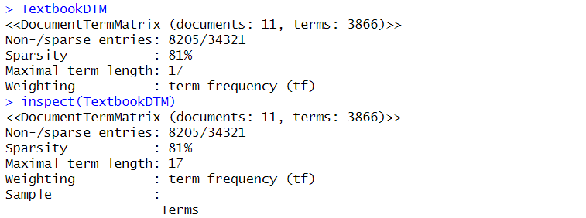

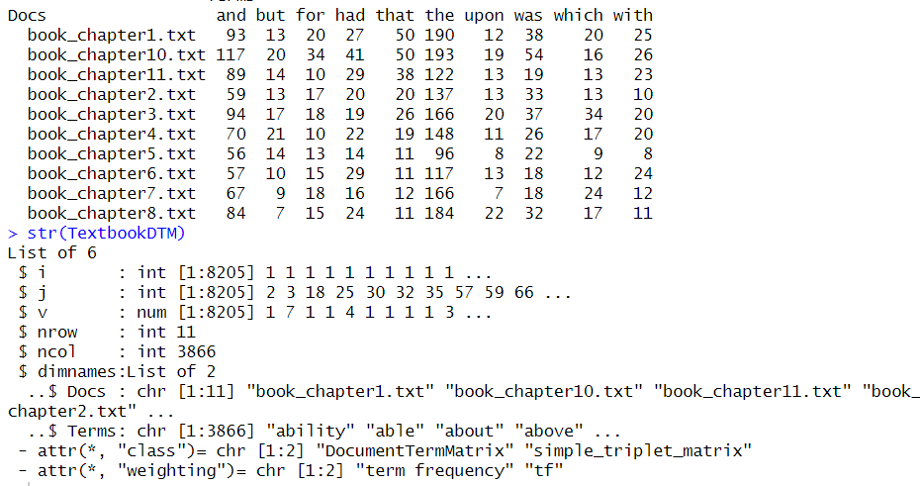

Figure 14

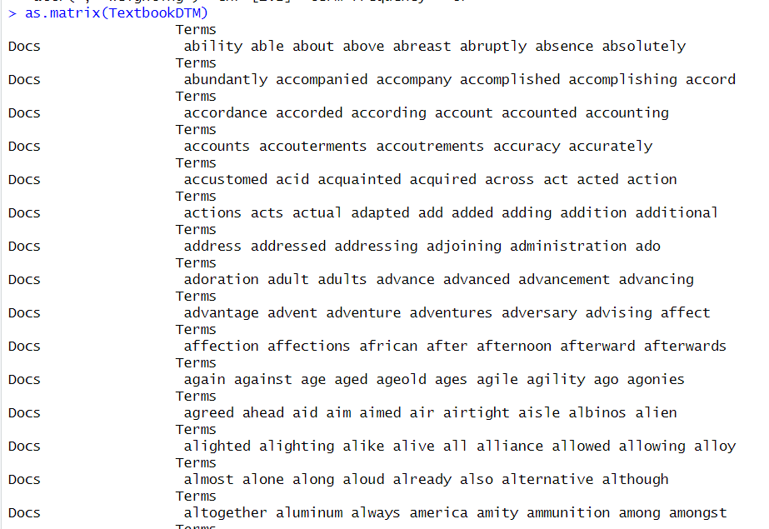

We will also remove the stopwords from our document to clean the data. To do so, we will use pre-defined set of words given by R in English. Post removal of stop words the content of the document looks as shown in Figure 15.

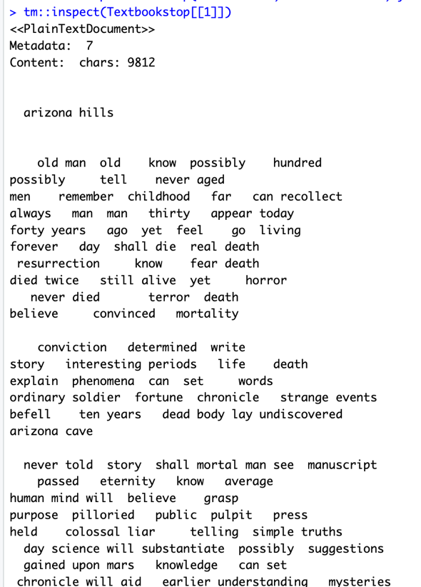

Figure 15

Post removal of stopwords we create TDM once again and then try to find terms that occur minimum 5 times in the document. We will also try to find the length of one of the frequent term.

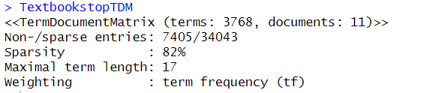

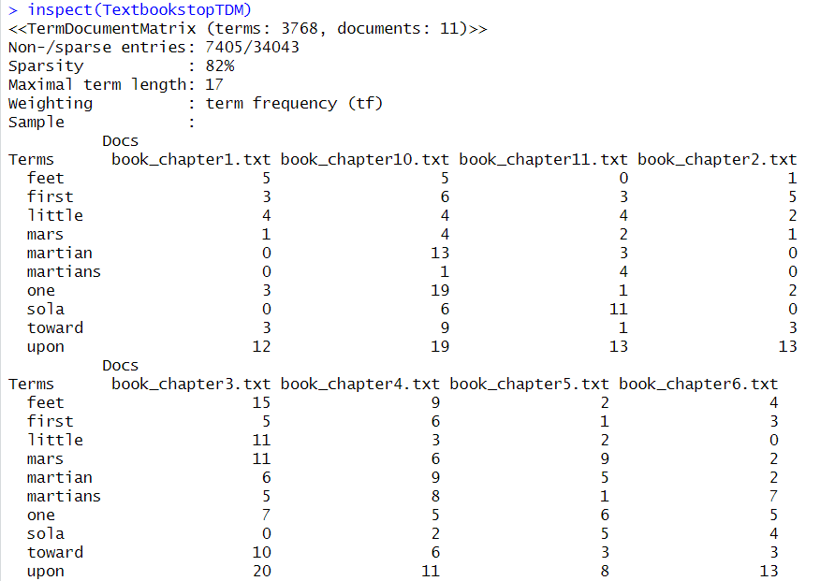

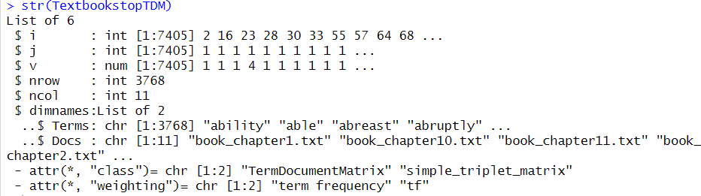

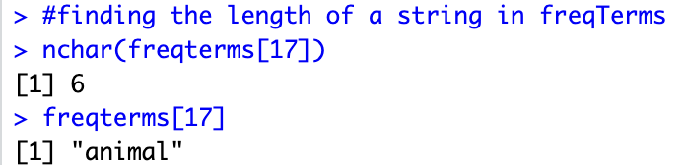

Figure 16

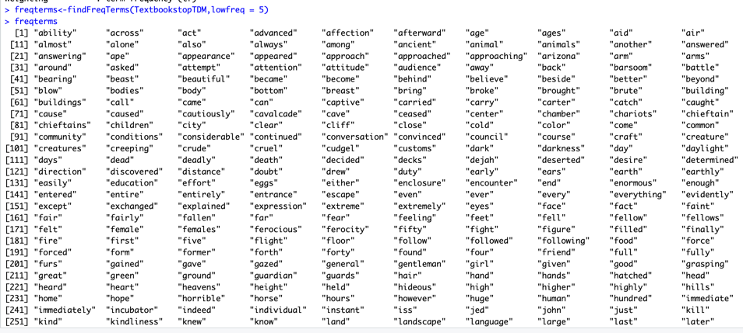

Figure 17

Term frequency for each of the words.

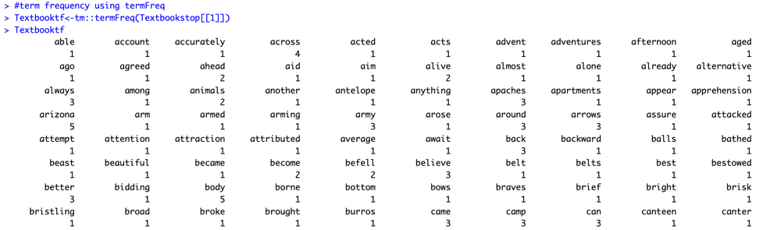

Figure 18

Inspecting TDM again.

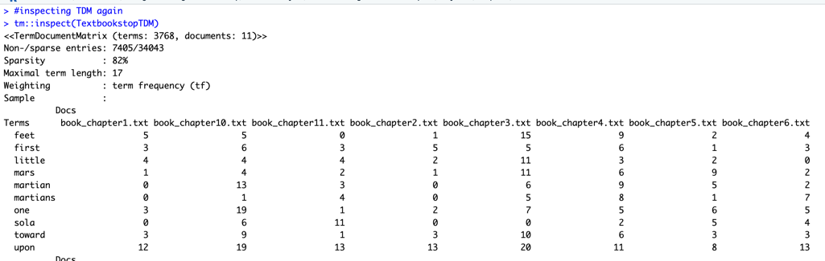

Figure 19

Plotting dendrogram. We can see in the Figure 20, that the dendrogram plotted is not much useful for us. Hence we try some more functions to get a good understandable plot.

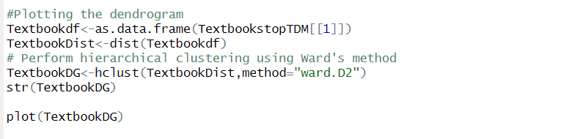

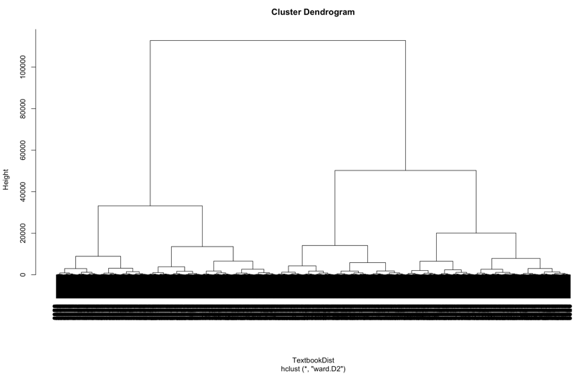

Figure 20

To plot a better dendrogram, we removed words with high sparsity and re-calculated the sparsity of each word. We created a new TDM and plotted the dendrogram.

First the term document matrix is converted to a matrix format.Then, a sparsity threshold of 0.83 is set. This means that words appearing in less than 83% of the documents will be removed from the term document matrix. The sparsity of each word is calculated and words with sparsity greater than the threshold are selected. A new term document matrix is created by selecting only the words with sparsity below the threshold. The new term document matrix is converted into a data frame, and a distance matrix is calculated using the dist() function. A dendrogram is then generated using hclust() function with "ward.D2" method, which is a hierarchical clustering method that minimizes the variance of the clusters being merged at each step. Finally, the dendrogram is plotted using the plot() function.

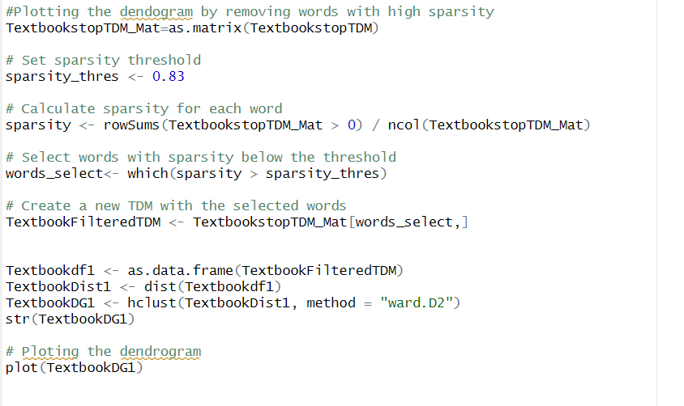

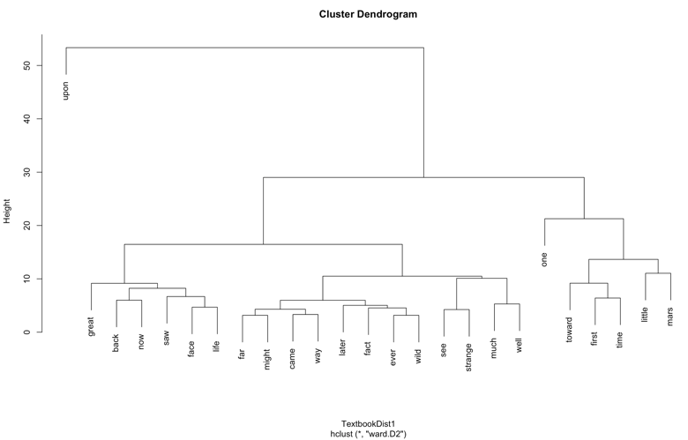

Figure 21

Below you will also find the dendrogram for each n (n = words of length).

Dendrogram with n =10 where n is the length of the words

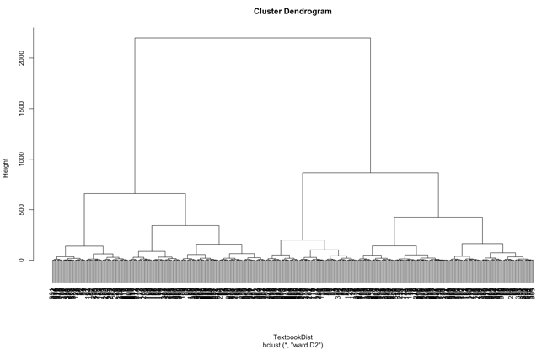

Figure 22

Dendrogram with n =12

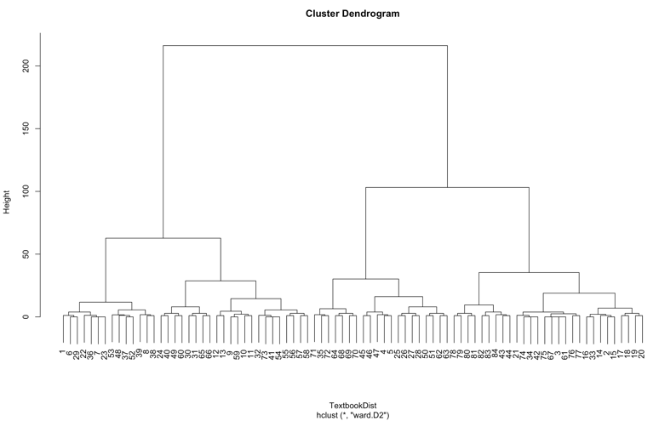

Figure 23

Dendrogram with n =13

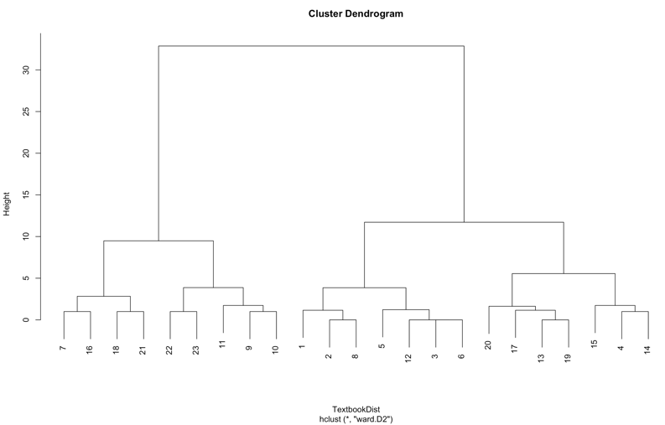

Figure 24

**Word cloud**:

A word cloud is a data visualization technique that represents textual data in the form of a visual image, in which the size of each word is proportional to its frequency or importance in the text. In a word cloud, more frequently occurring words appear larger and bolder, while less frequently occurring words appear smaller and fainter. Word clouds are commonly used to gain insight into the most prominent themes or topics present in a text.

Now, in the code, words is a vector of unique words obtained from the term frequency table Textbooktf. pal is a color palette generated using the brewer.pal() function from the RColorBrewer package.

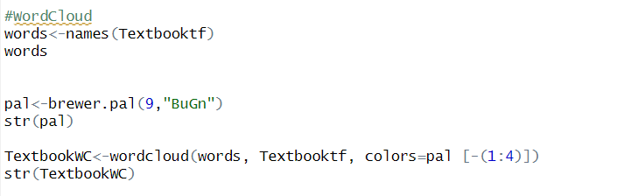

We will generate different word clouds using different palette of colors.

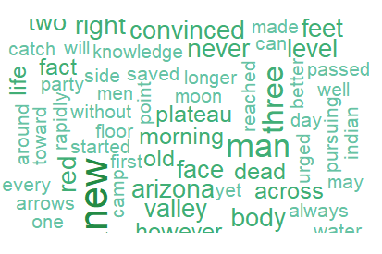

Figure 25

Word cloud with a different palette.

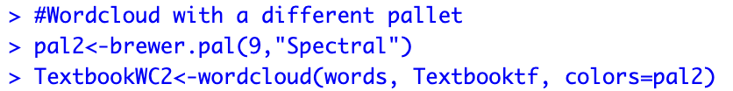

Figure 26

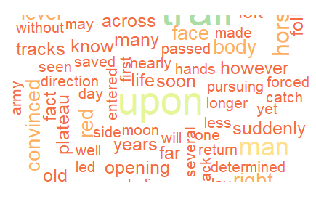

Figure 27

**QUANTEDA:** An R package for text analysis that provides a comprehensive set of tools for managing, analyzing, and visualizing textual data. It offers a range of functionalities, including text preprocessing, tokenization, document-feature matrix creation, topic modeling, and sentiment analysis, among others.

Using the “QUANTEDA” package, we took the first 15 lines of the document.

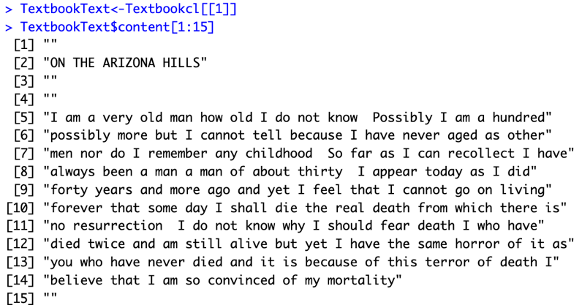

Figure 28

Next step is tokenizing each word of the document.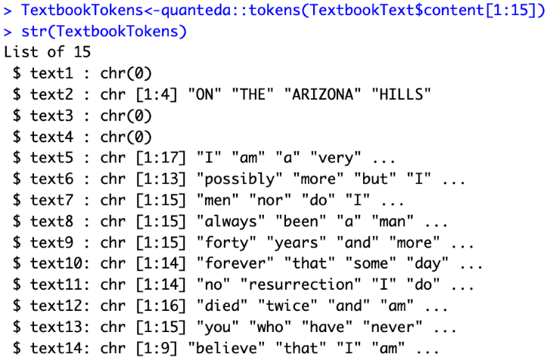

Figure 29

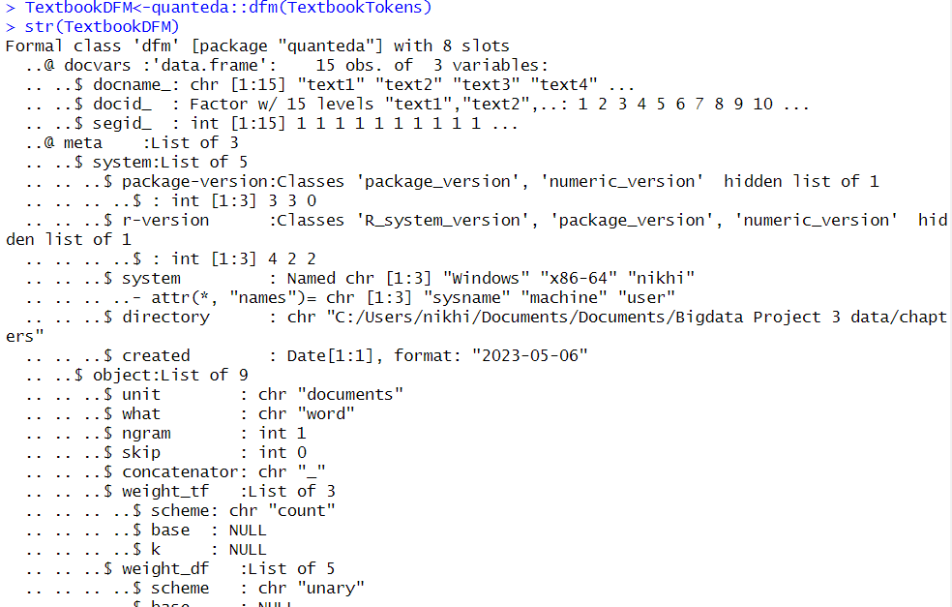

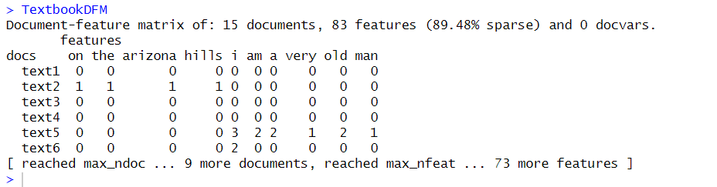

Frequency of terms in document term matrix.

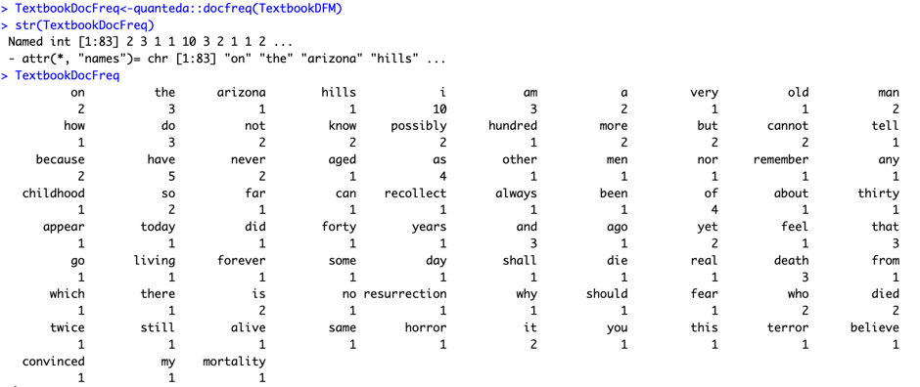

Figure 30

Assigning weight to the words found in DTM

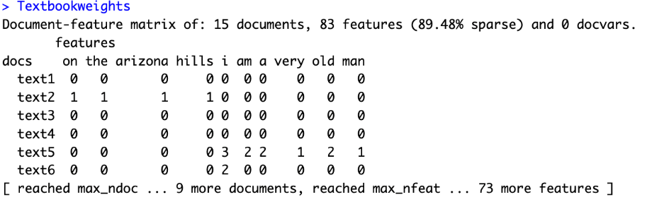

Figure 31

Applying TF-IDF to the document.

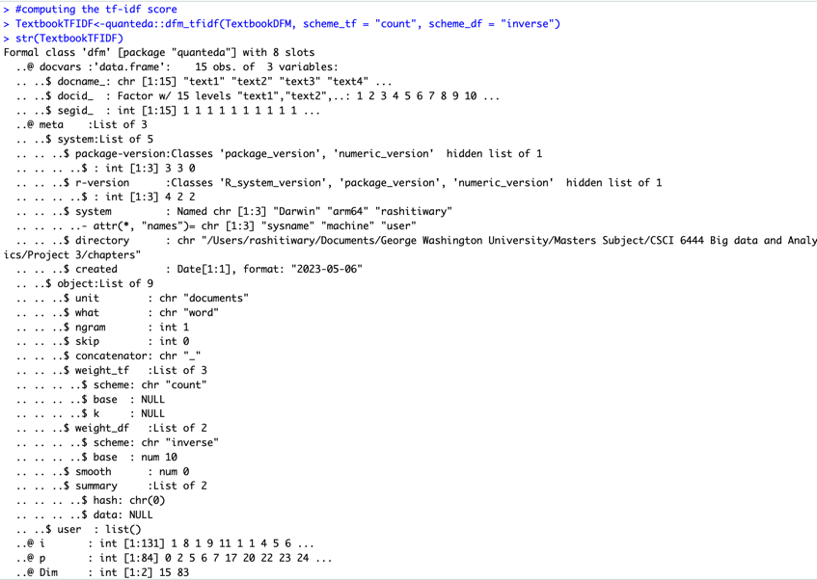

**SYUZHET:** Syuzhet is an R package that provides a simple interface to various sentiment analysis tools, including sentiment dictionaries and algorithms. The package includes several built-in dictionaries that allow the user to analyze text sentiment using a simple interface.

The Syuzhet package provides the following sentiment dictionaries: AFINN, Bing, NRC, and GI. Additionally, it includes several sentiment analysis algorithms, including the "syuzhet" algorithm, which is a simple sentiment analysis algorithm based on the AFINN dictionary.

An R package for the extraction of sentiment and sentiment-based plot arcs from text. Extracting the text sentences in the text file. Figure 33 shows the result of the document as the dataframe. Figure 34 shows the results of document as a string.

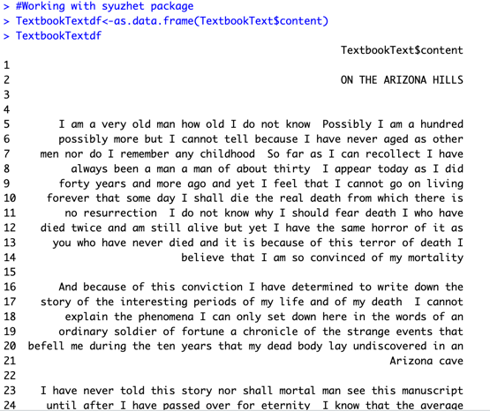Sentiment analysis on chapter 1:

Figure 33

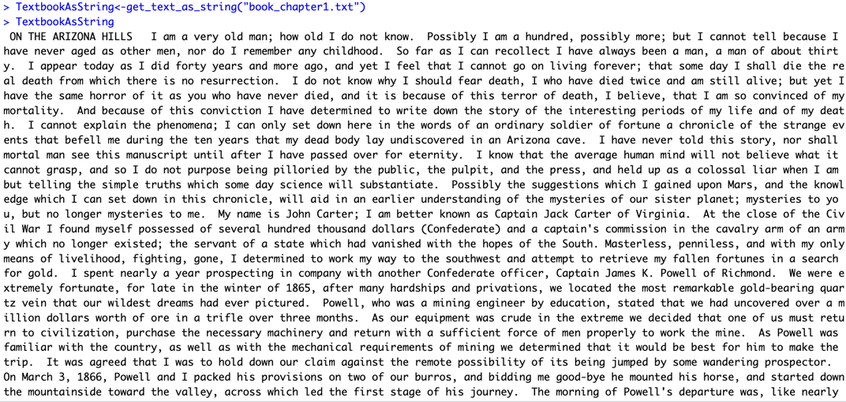

Figure 34

We will now parse through the document string we created in Figure 34 and get individual sentences.

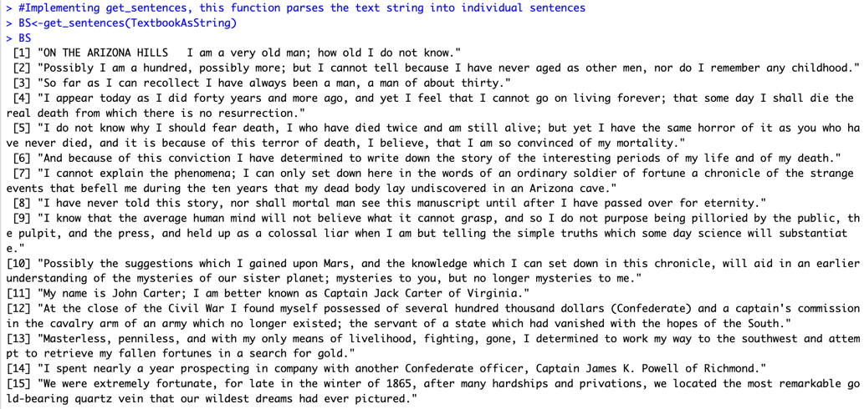

Figure 35

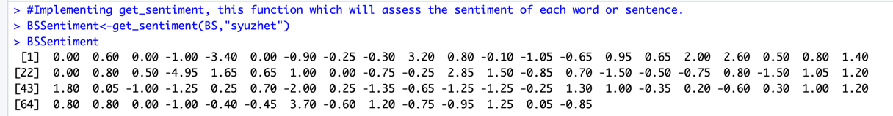We will perform sentiment analysis on the sentences to the text using the “syuzhet” as the default value.

Figure 36

“Syuzhet” has different package to experiment with like – “bing”, “afinn”, “nrc” and “Stanford”.



Figure 37

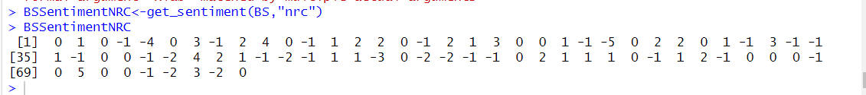

To analyze the sentiment of the text "Prince of Mars" using the Bing sentiment lexicon, we employ the syuzhet package. The Bing sentiment dictionary is obtained by using the get_sentiment_dictionary() function.

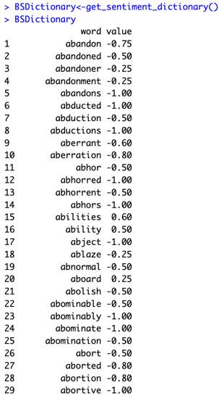

Figure 38

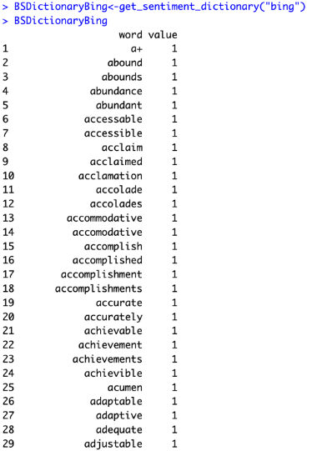First few terms of bing dictionary.

First few terms of NRC dictionary

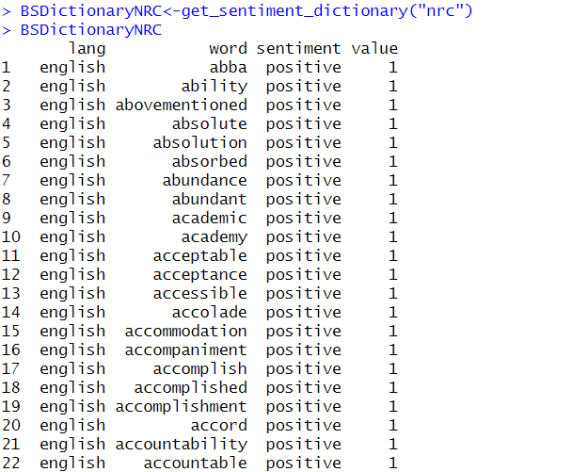

* Sum of values of sentiment vector to understand the overall emotion of the text

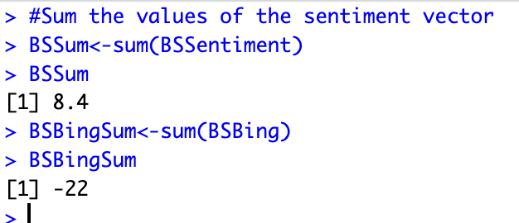

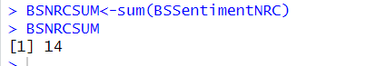

Figure 40

The mean of all the methods in the text

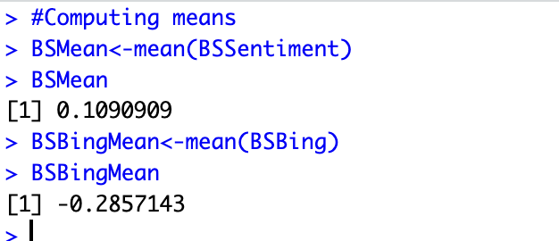

Figure 41

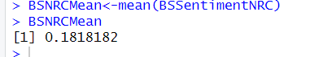

Plot for the BSSentiment

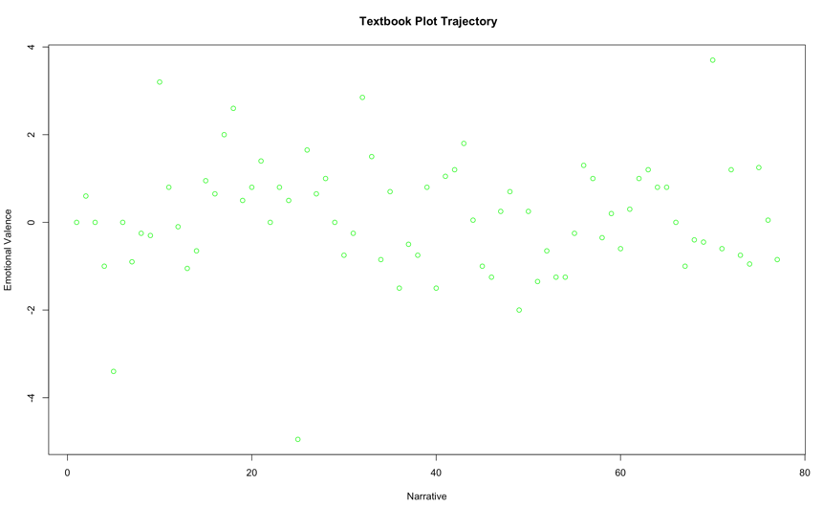

Figure 42

* Plot for BSSentiment with “bing” value

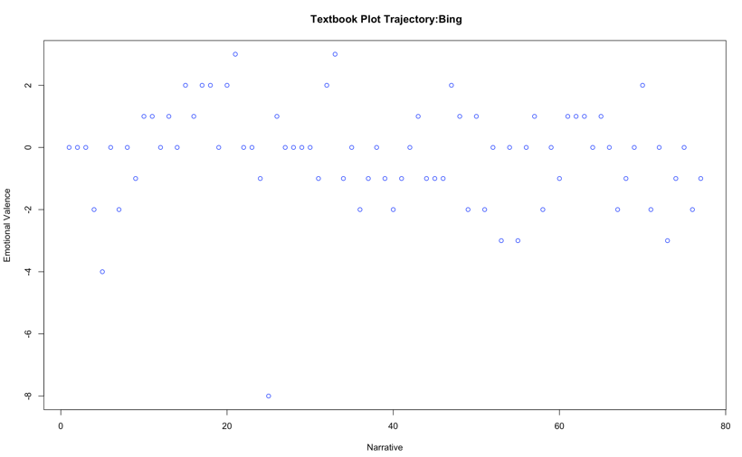

Figure 43

* Plot for BSSentiment with “nrc” value

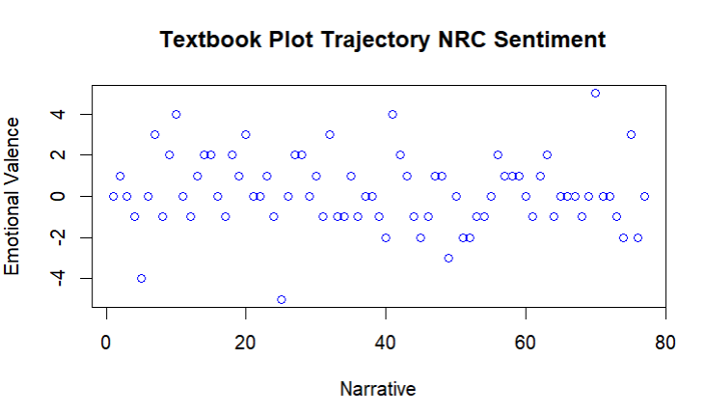

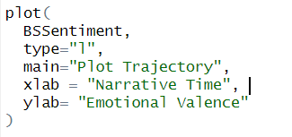

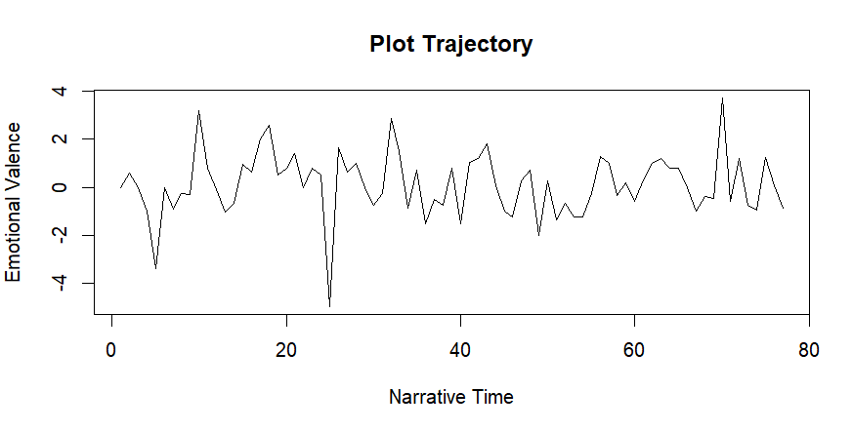

To compare different values, “get_percentage_values” is used. It calculates mean sentiment valence for each.



Figure 44

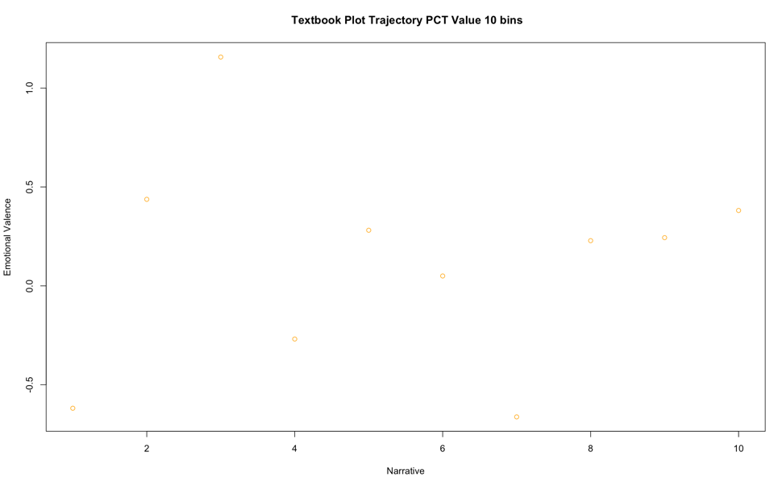

Figure 45

* 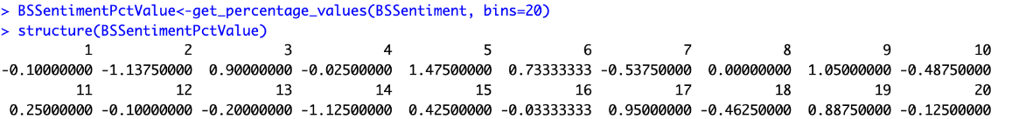Plotting with 20 bins

Figure 46

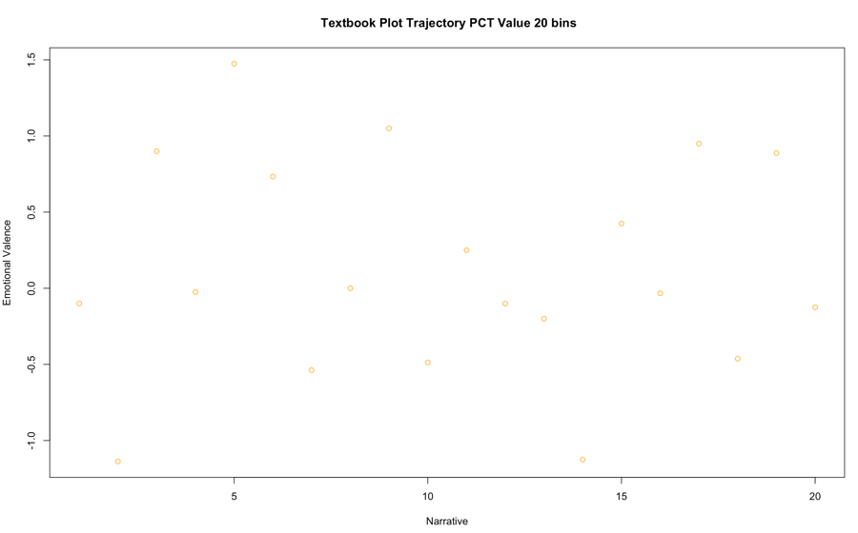

Figure 47

Function **computeSentiment** which computes the sentiment values, mean and sum values of a given text using the syuzhet, bing and nrc sentiment dictionaries.

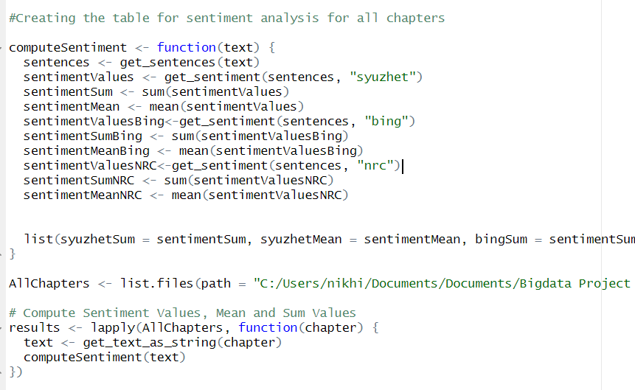

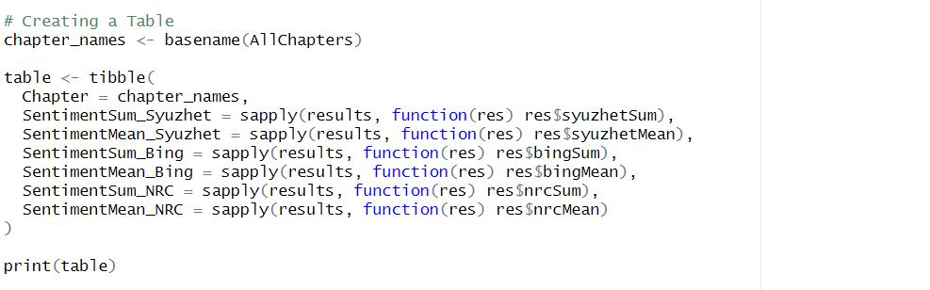

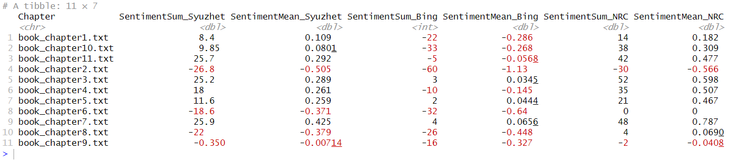

**Sentiment Analysis for Chapter 2:**

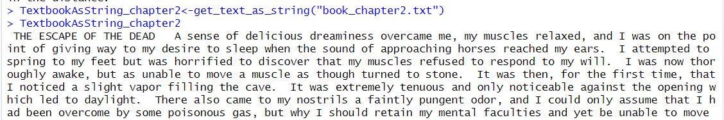

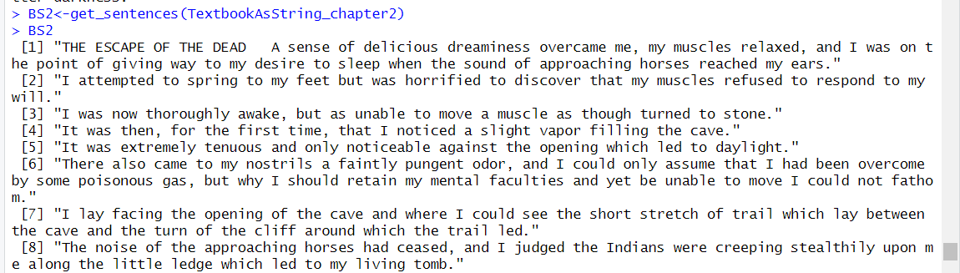

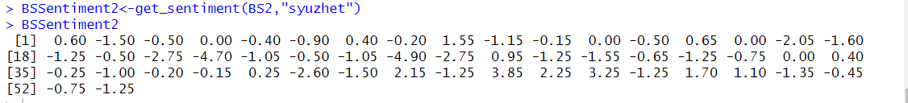

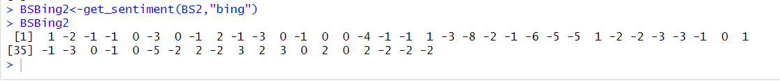



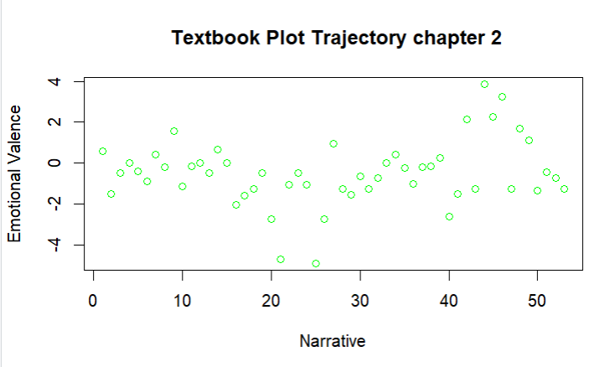

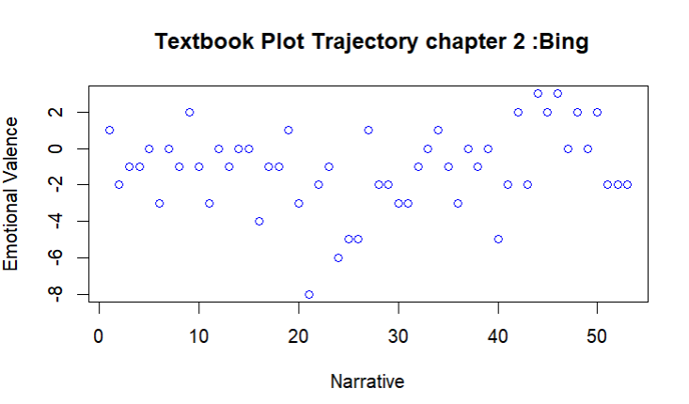

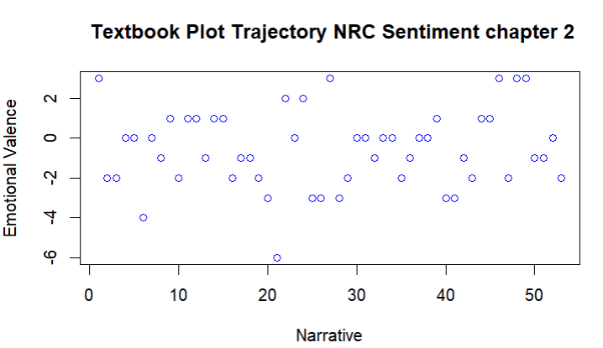

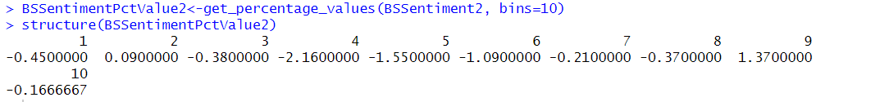

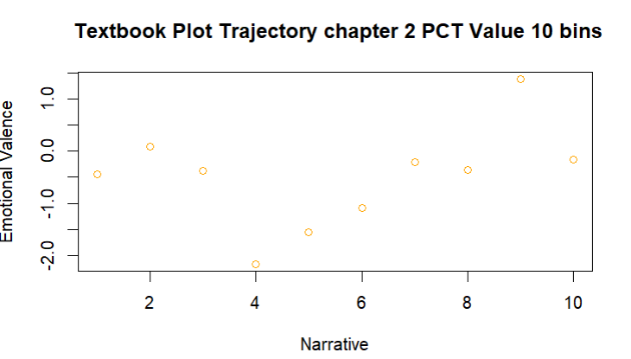

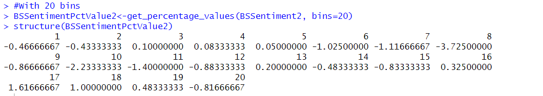

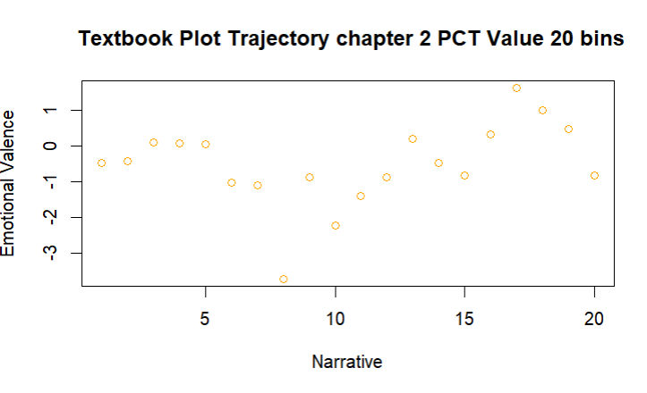

**Sentiment Analysis for Chapter 3:**

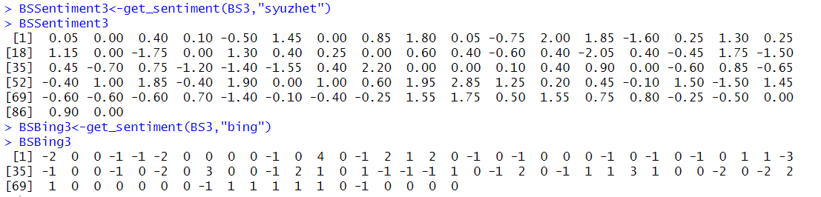

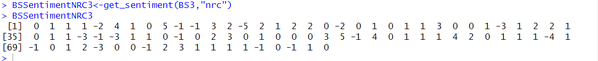

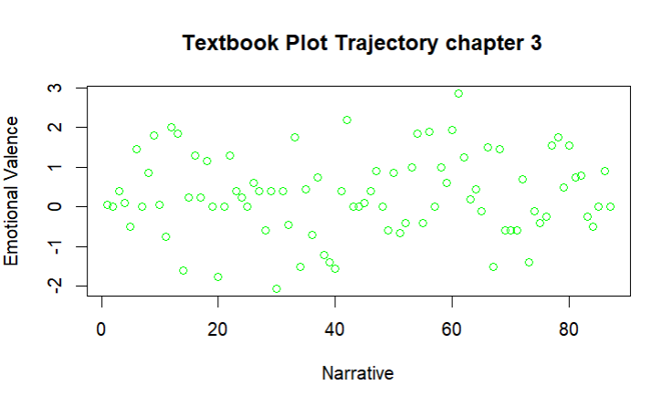

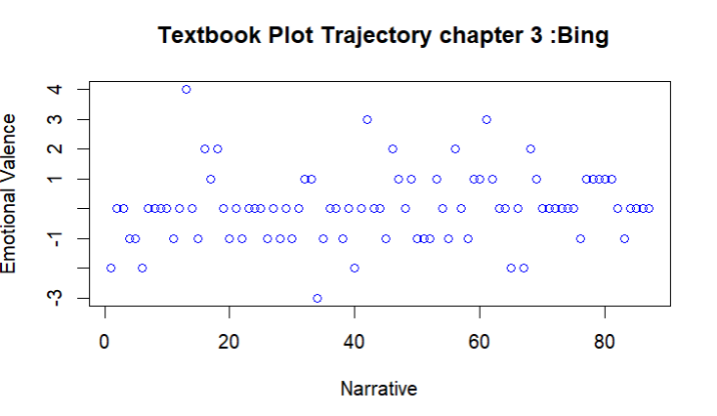

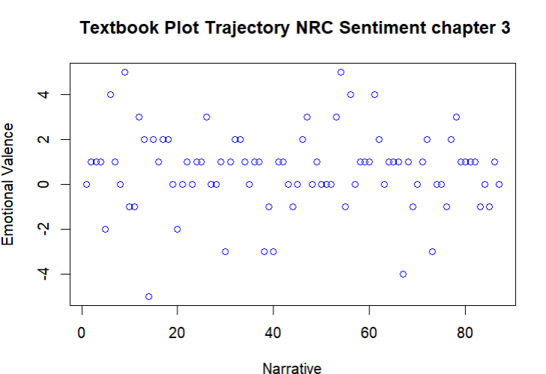

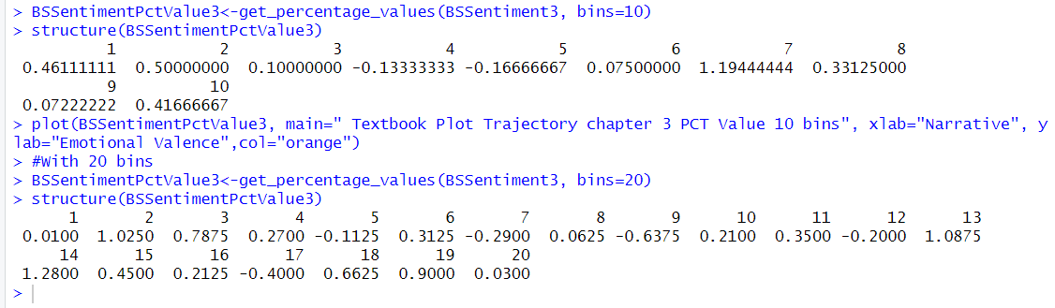

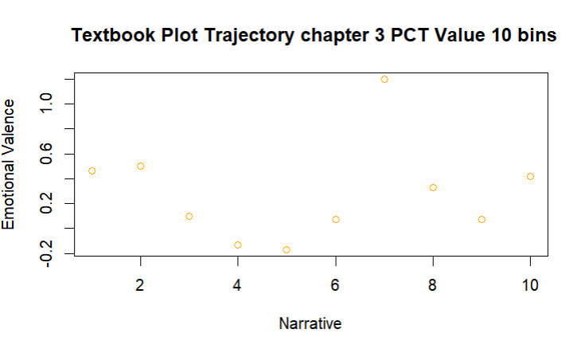

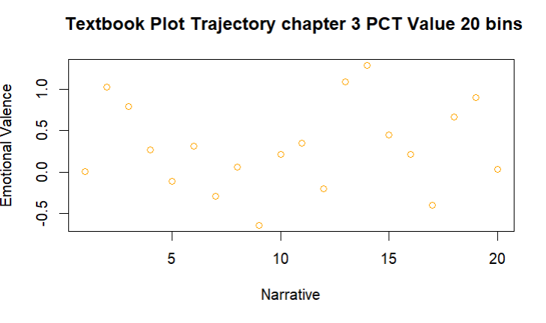

**Sentiment Analysis for Chapter 4:**

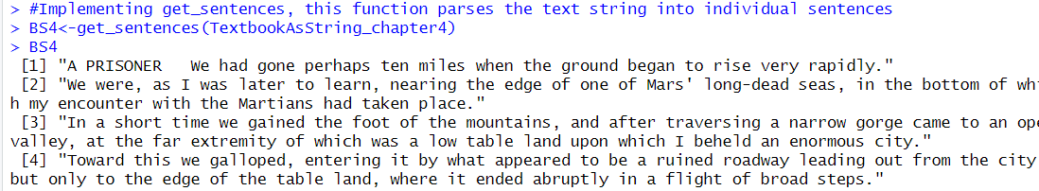

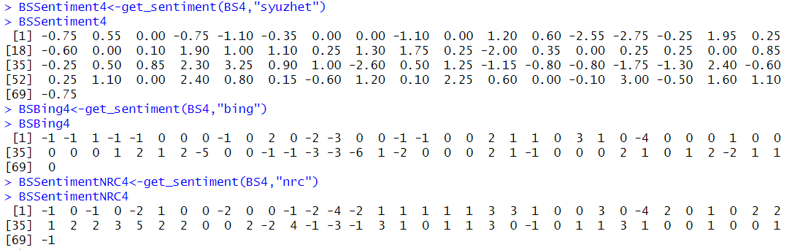

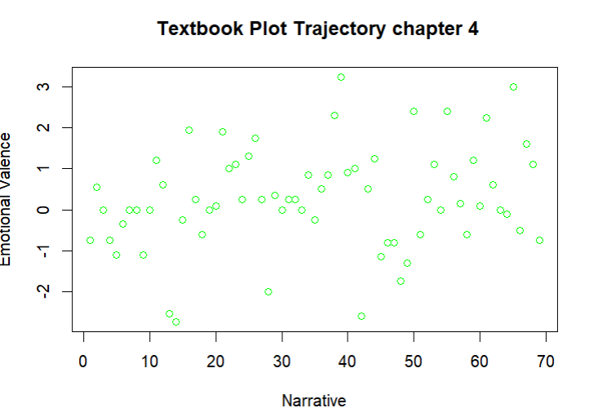

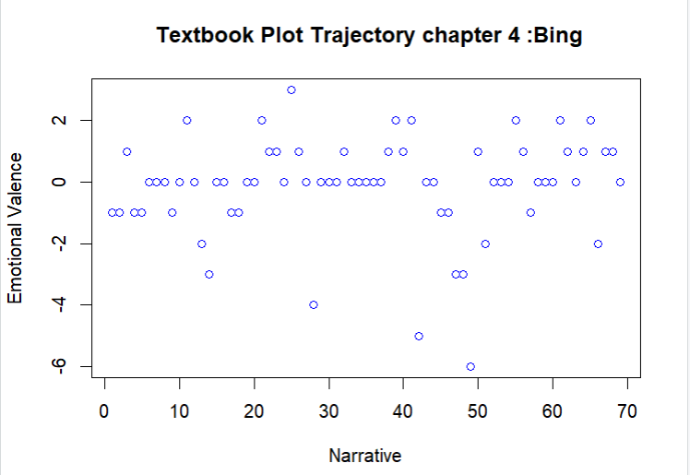

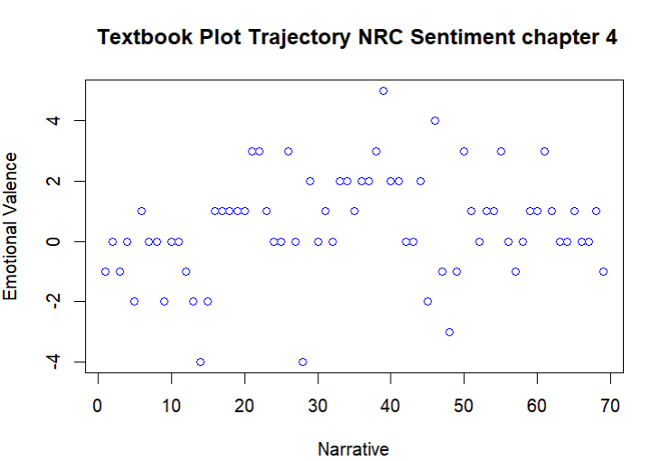

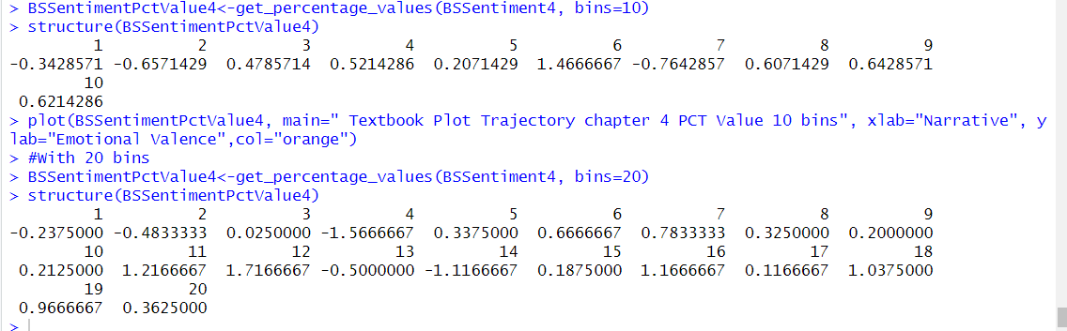

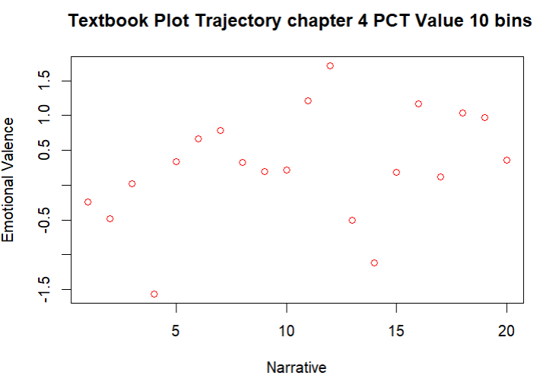

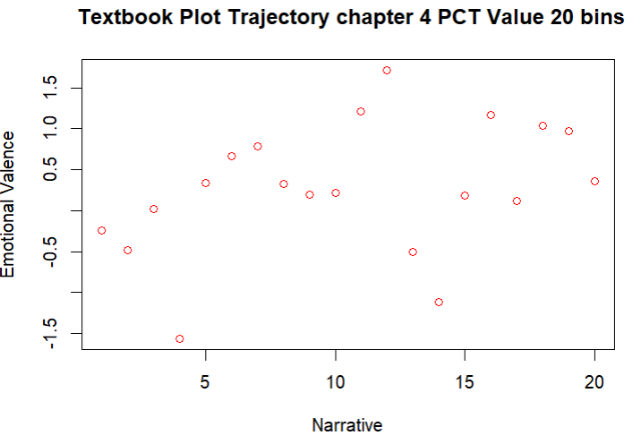

**Sentiment Analysis for Chapter 5:**

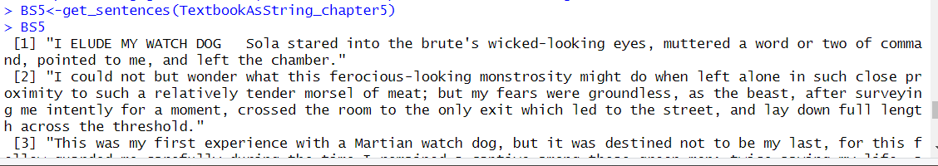

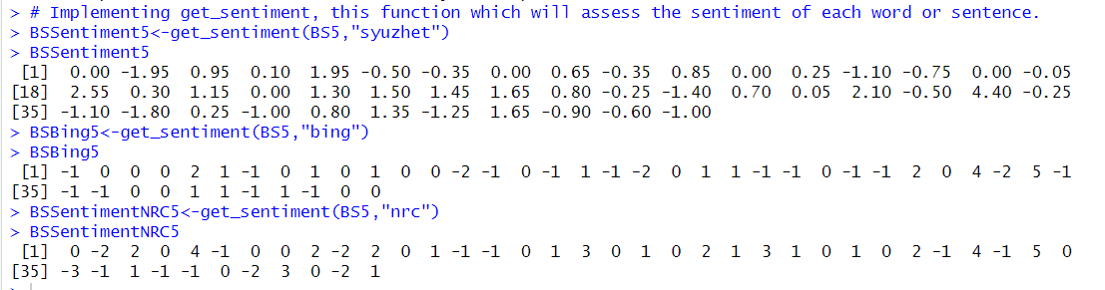

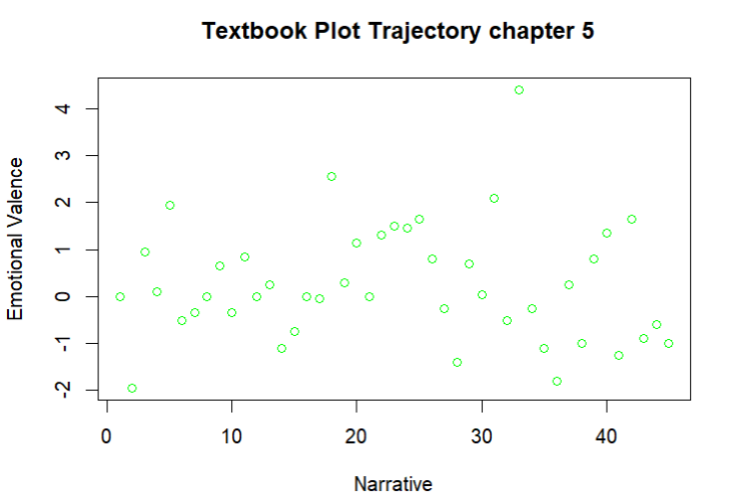 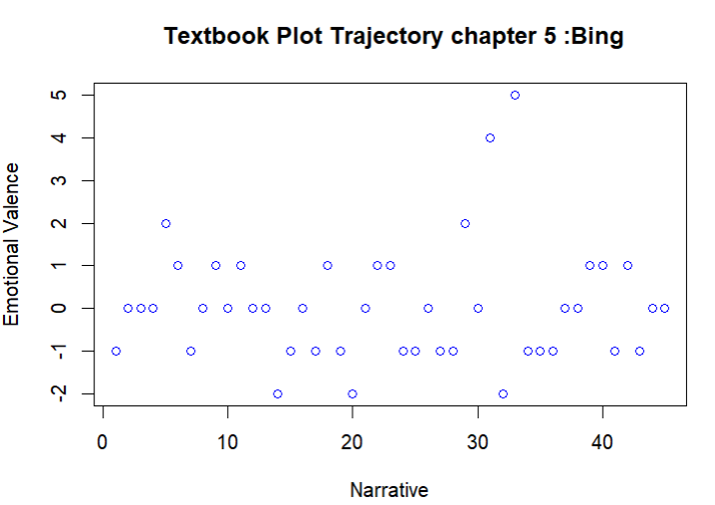

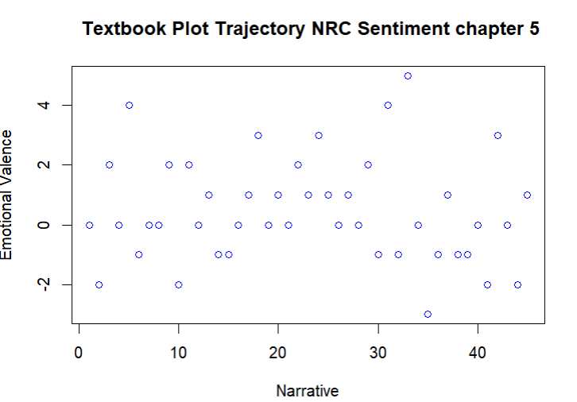

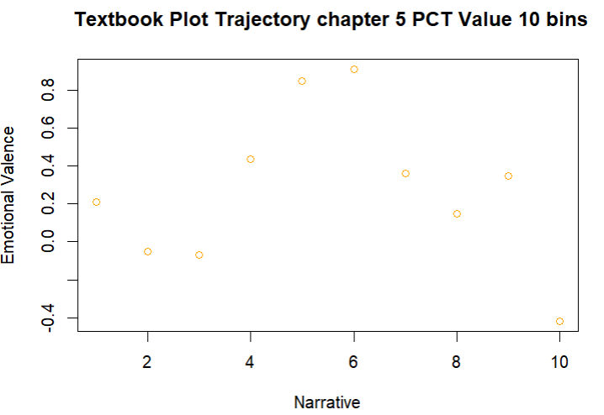

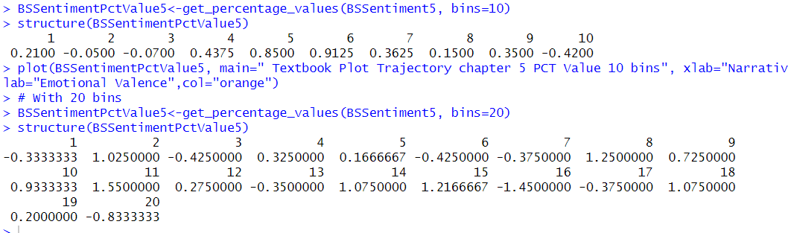

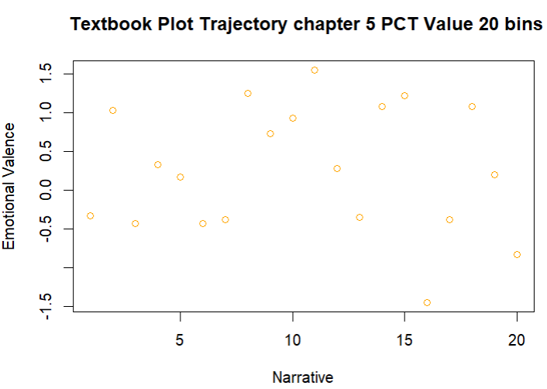

**Sentiment Analysis for Chapter 6:**

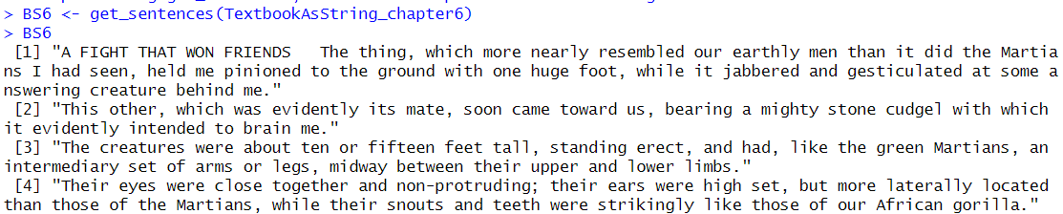

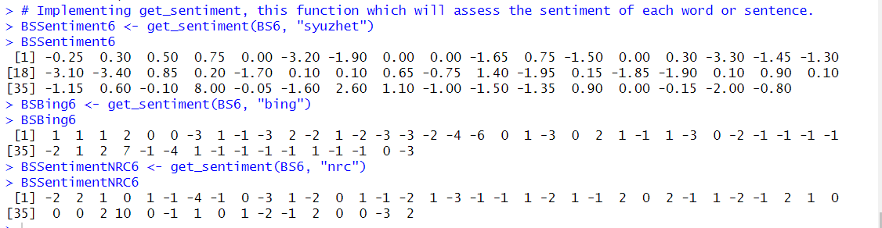

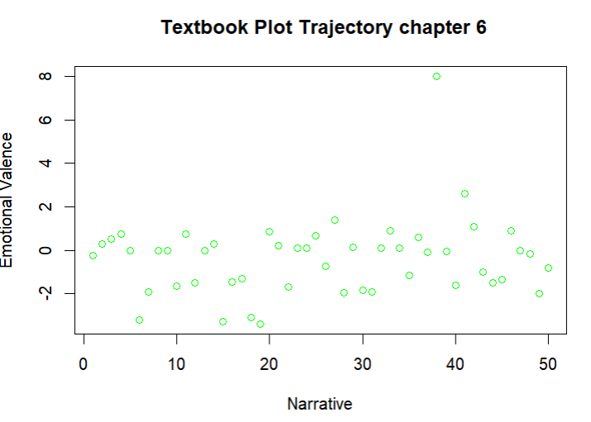

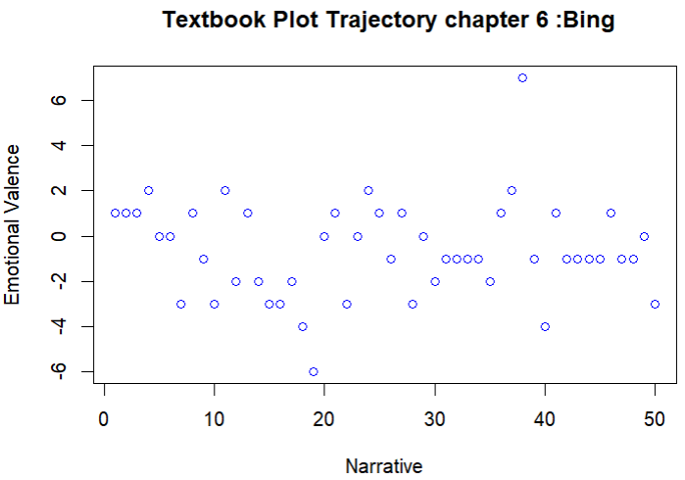

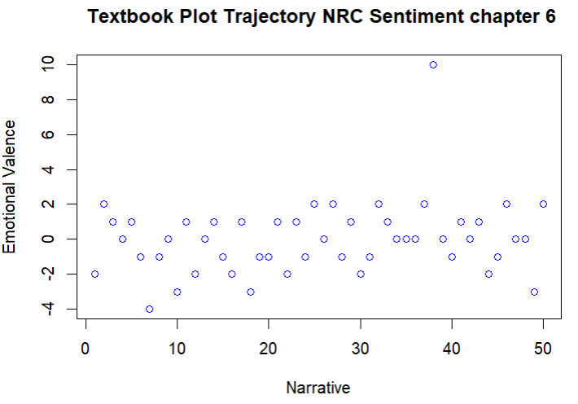

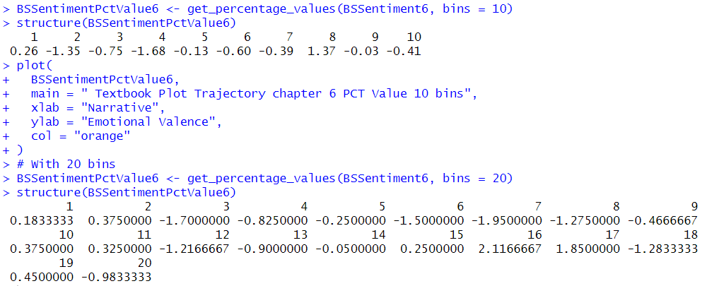

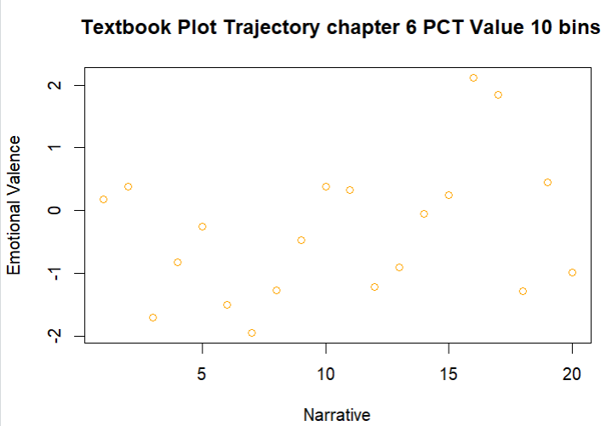

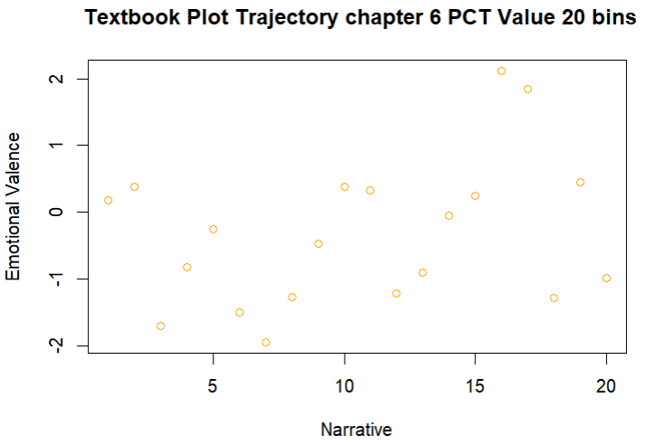

**Sentiment Analysis for Chapter 7:**

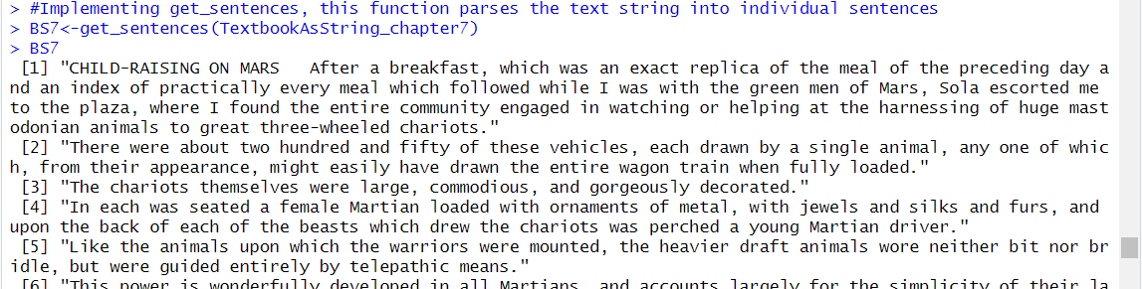

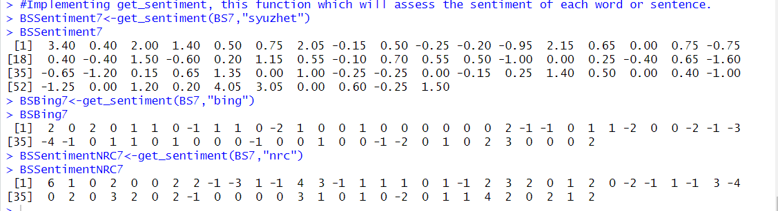

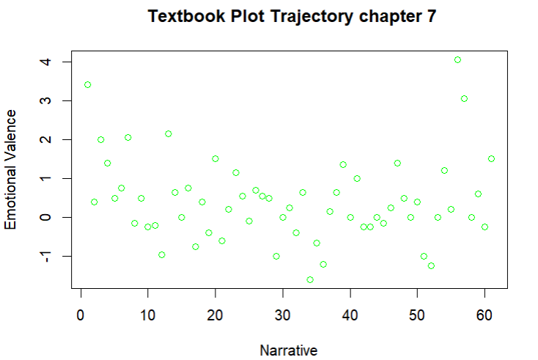

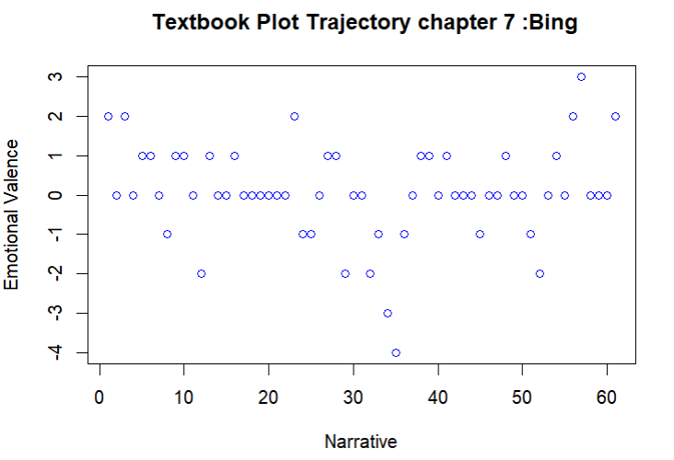

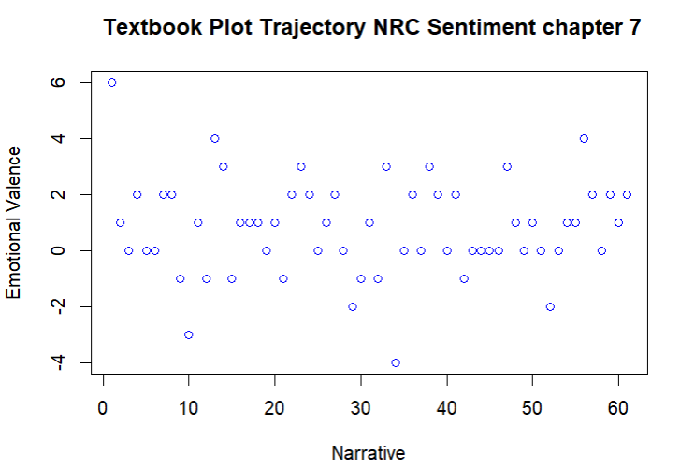

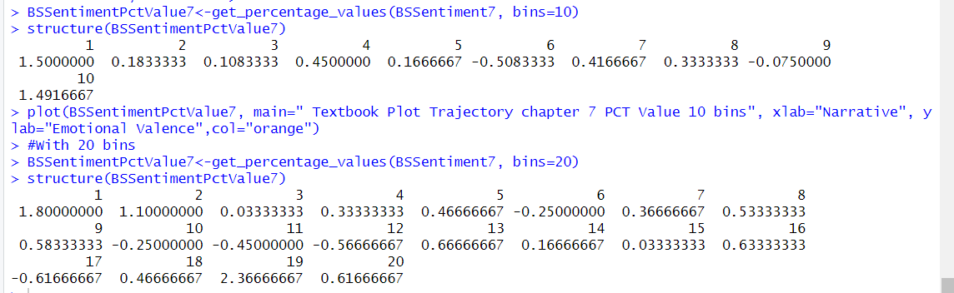

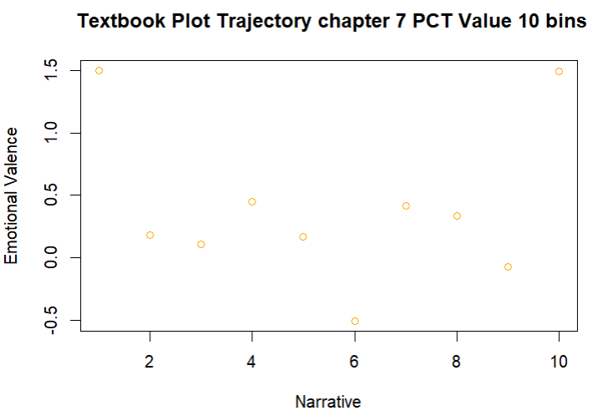

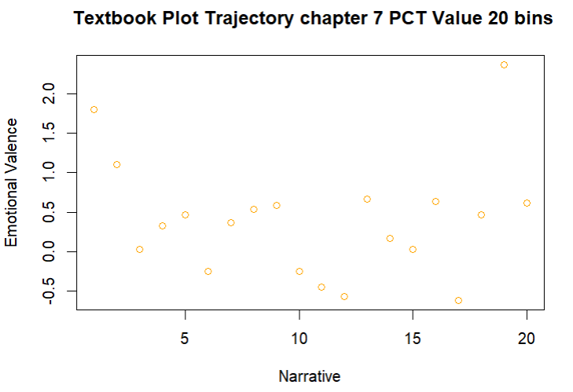

**Sentiment Analysis for Chapter 8:**

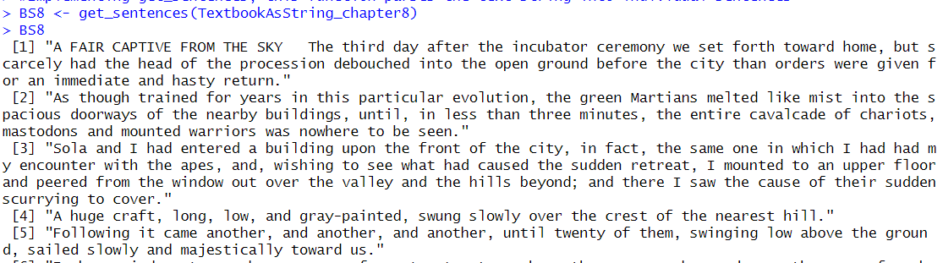

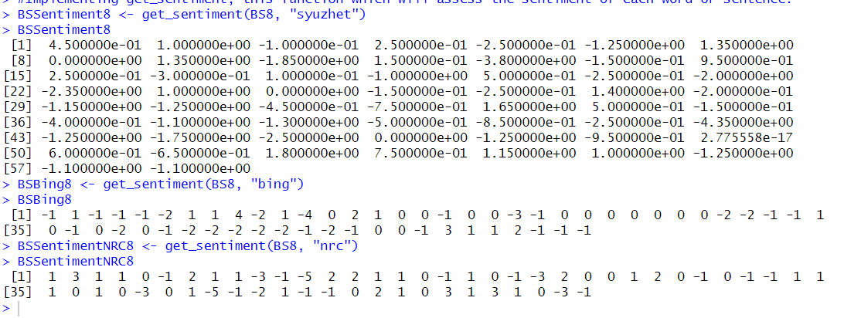

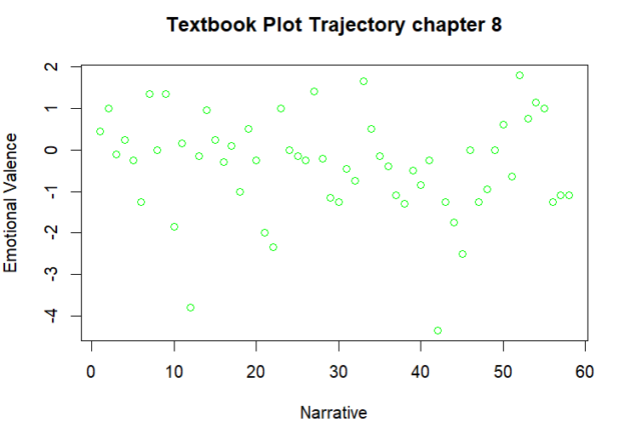

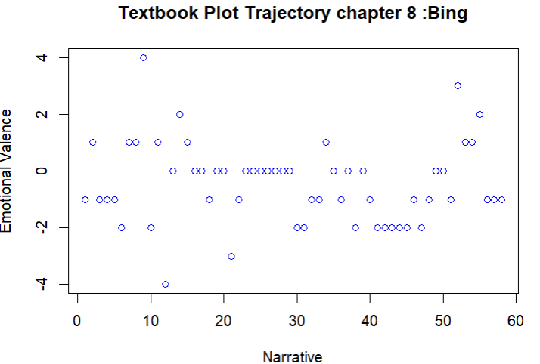

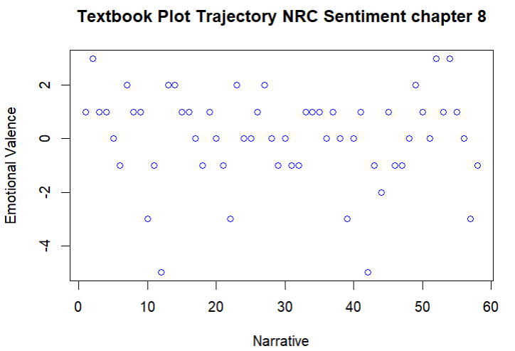

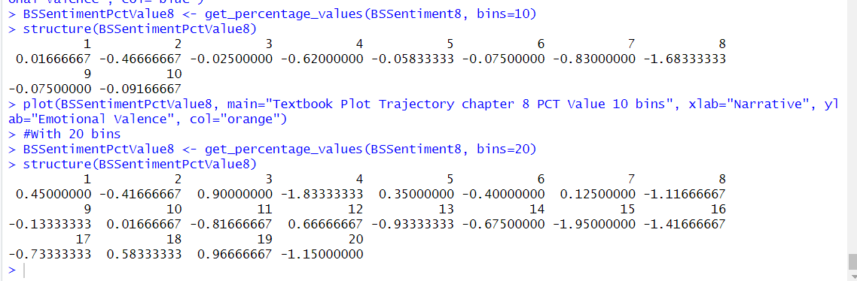

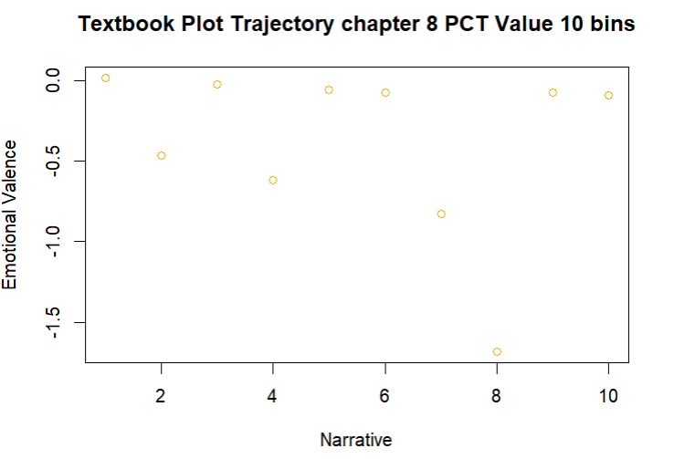

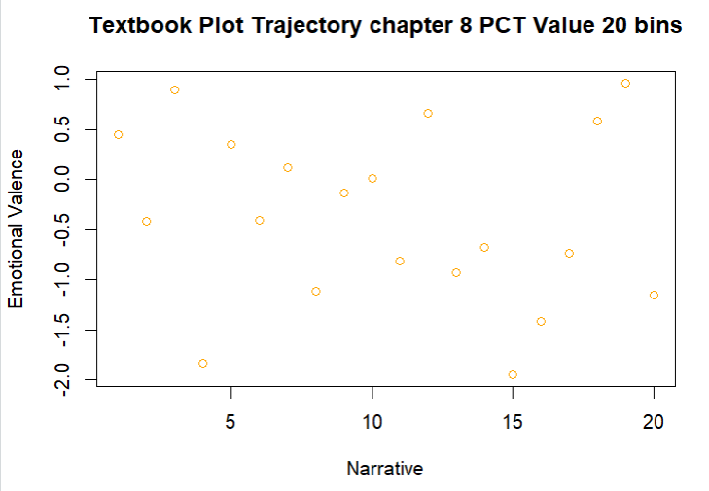

**Sentiment Analysis for Chapter 9:**

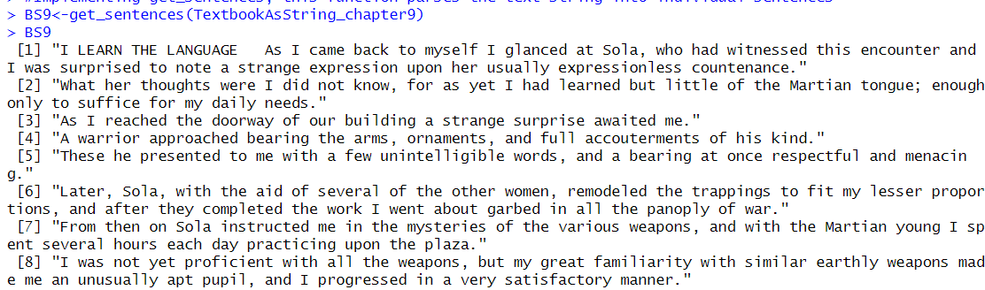

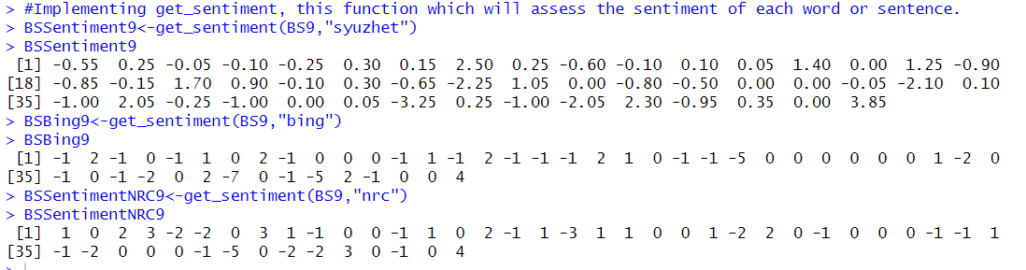

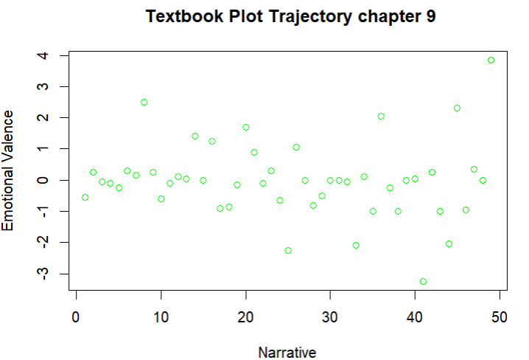

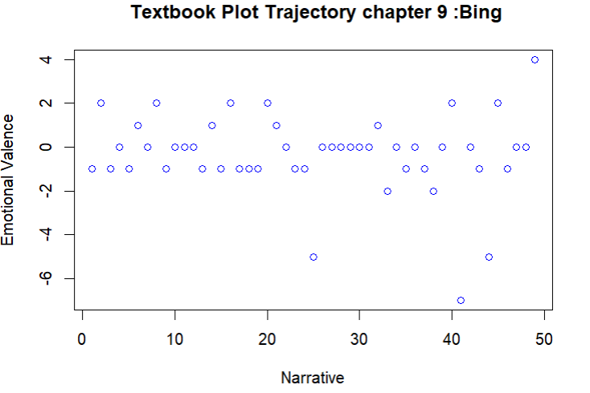

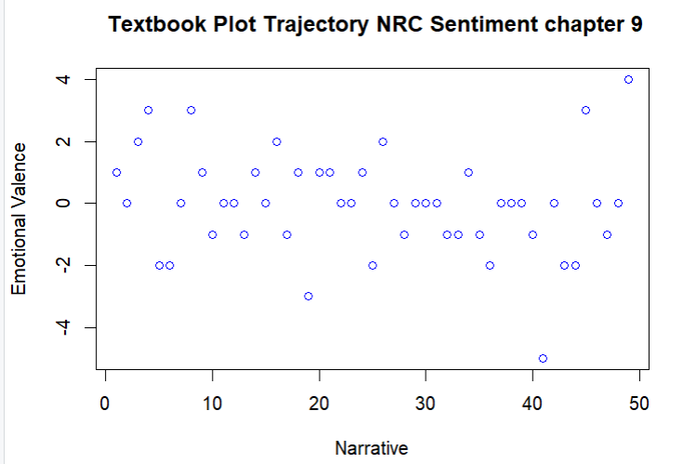

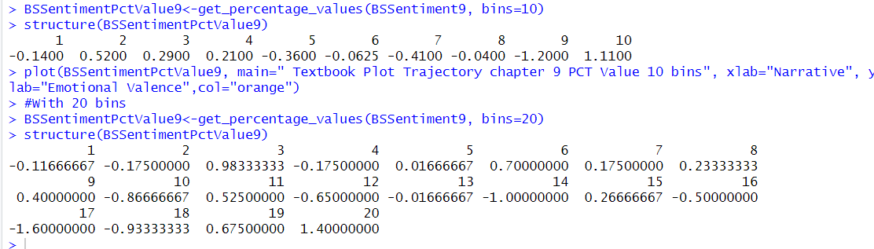

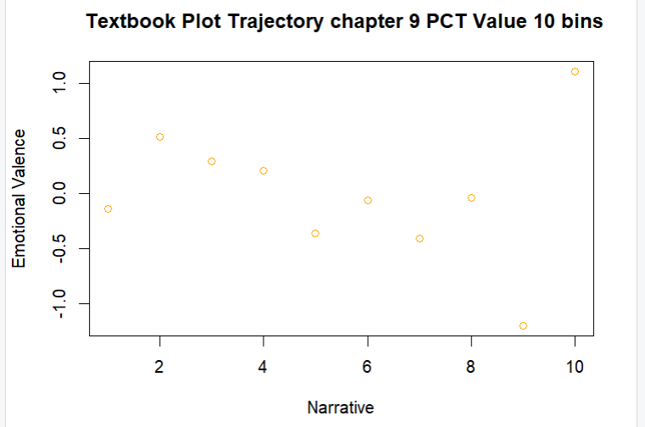

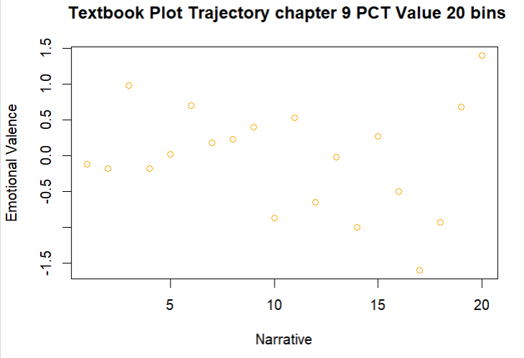

**Sentiment Analysis for Chapter 10:**

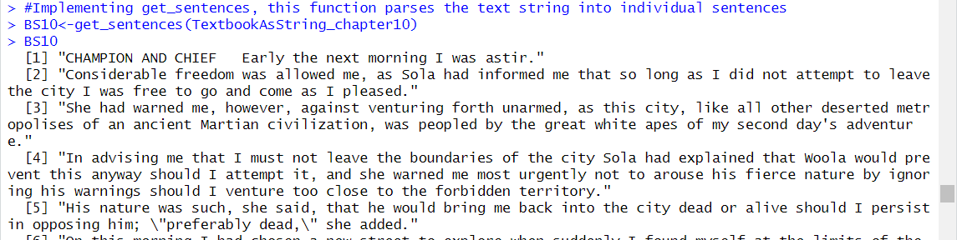

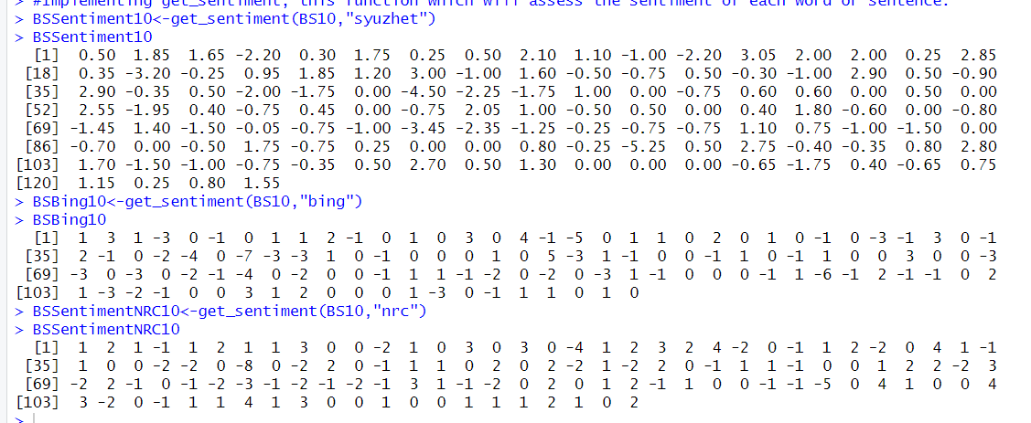

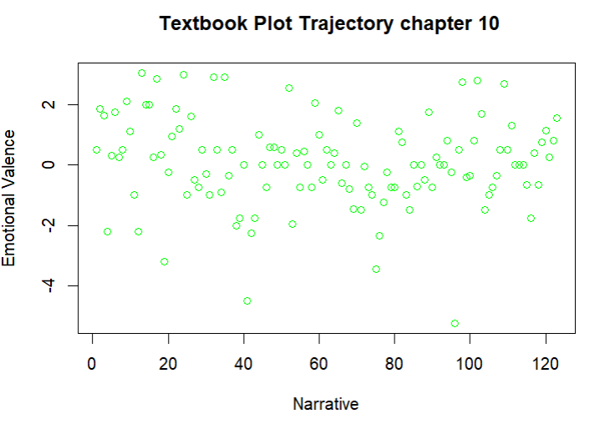

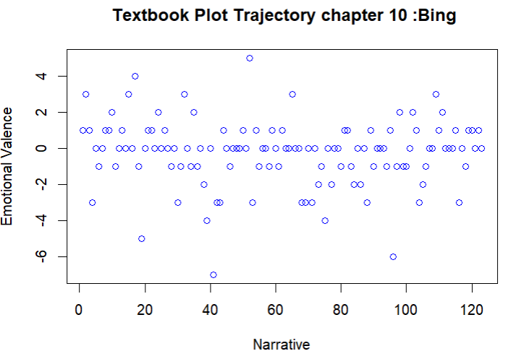

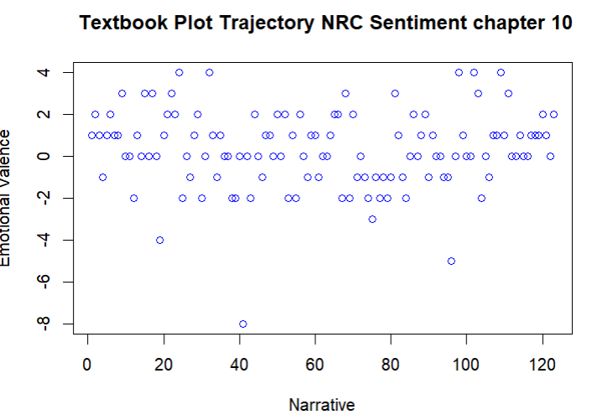

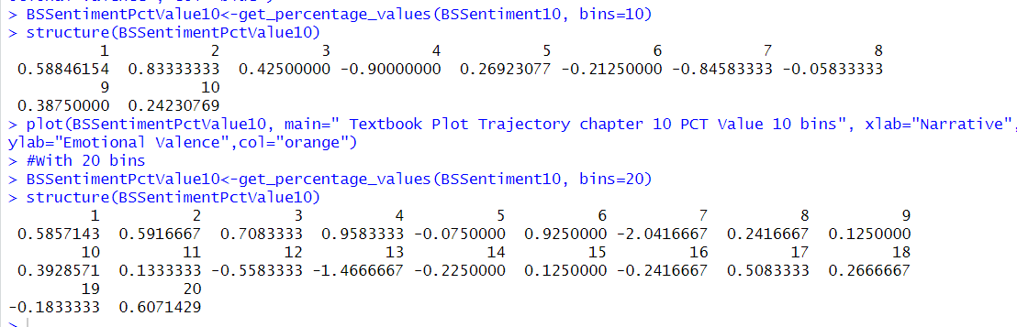

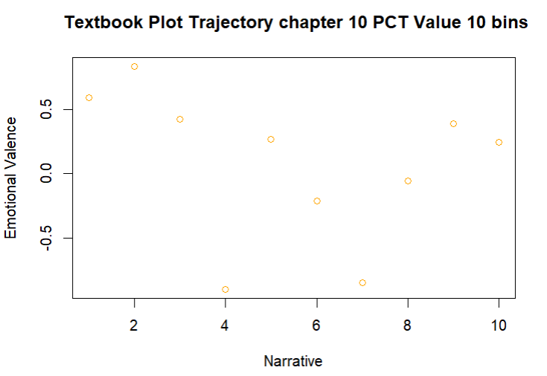

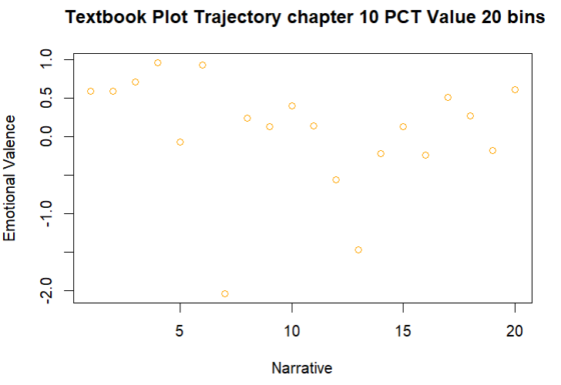

**Sentiment Analysis for Chapter 11:**

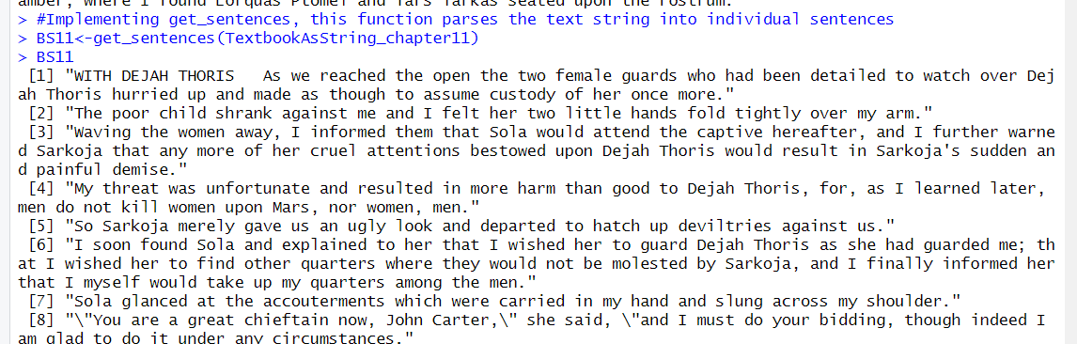

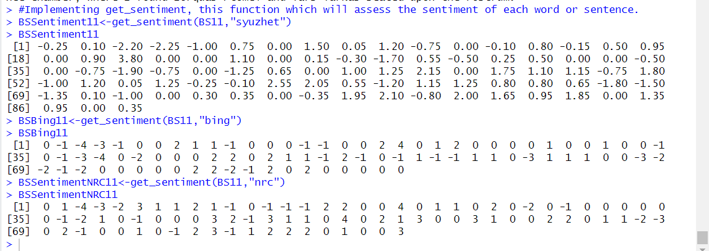

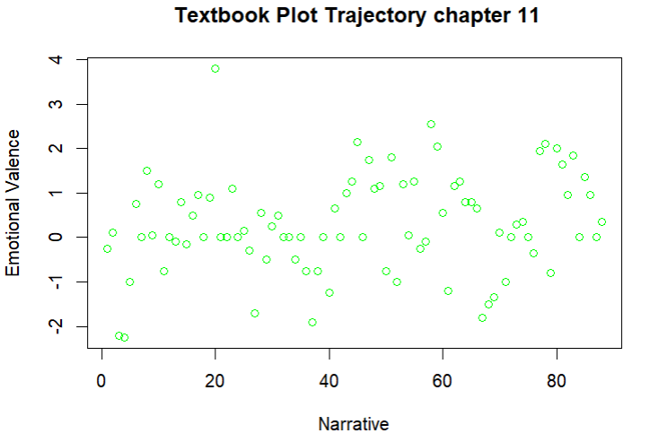

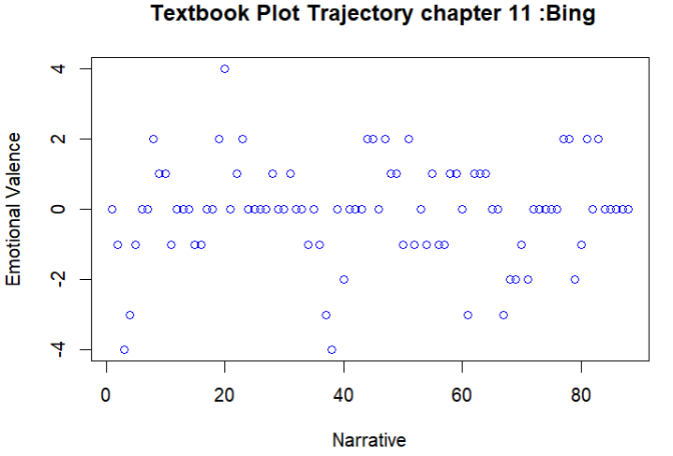

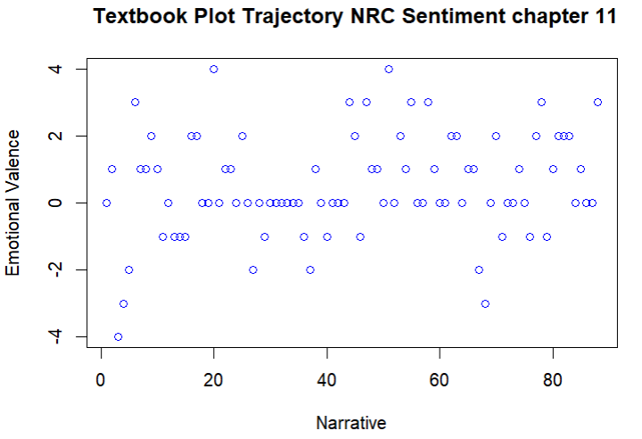

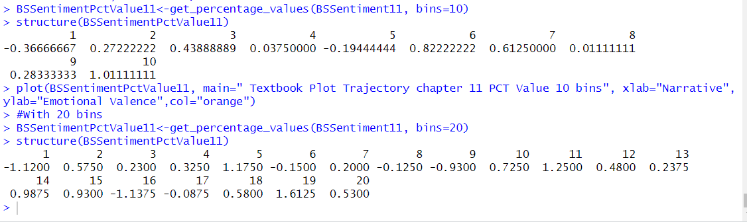

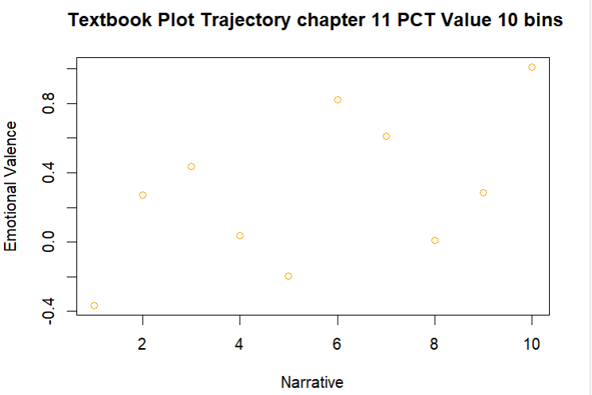

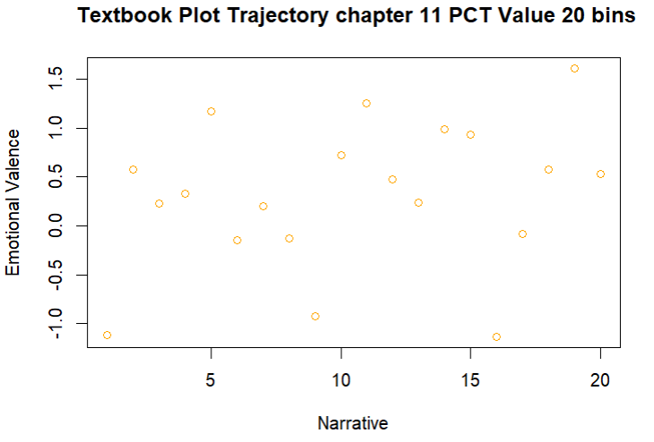

1. **Exploring Quanteda:**

* Top features of the document term matrix

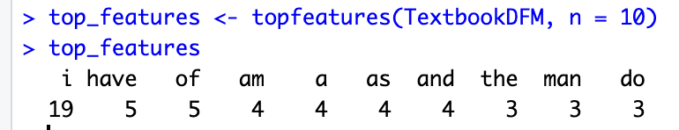

Figure 48

* Removal of terms from a document-feature matrix that appear fewer than min_docfreq documents or have a term frequency of less than min_termfreq

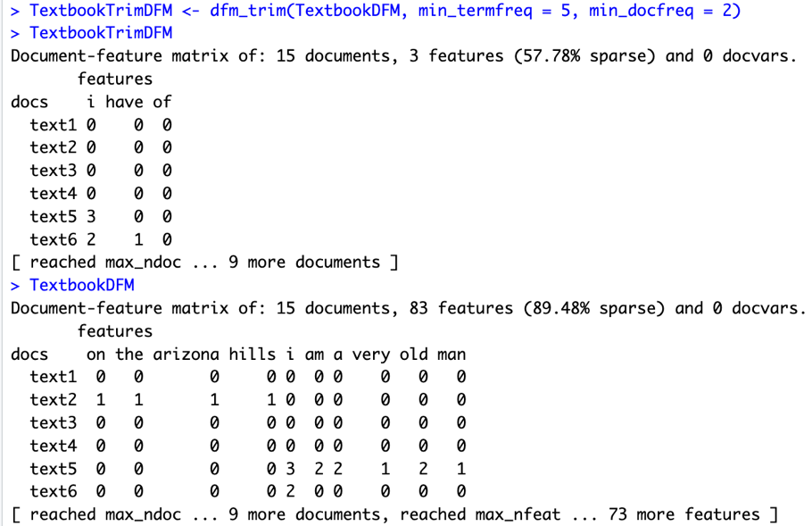

Figure 49

* kwic() function is used to retrieve keywords in context. It returns a list of number of results with the keyword and its context for each occurrence in the corpus.

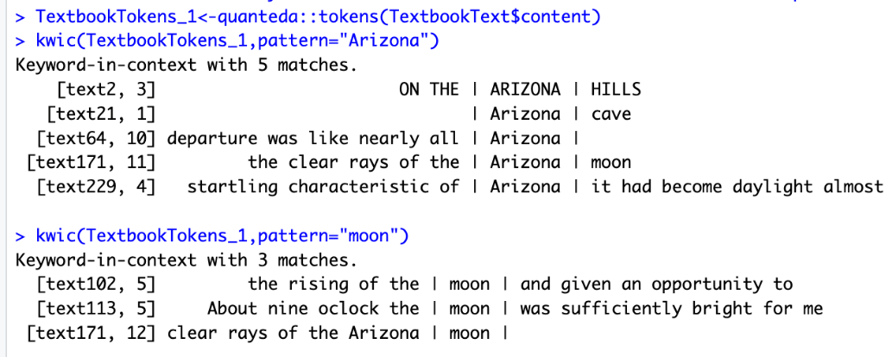

Figure 50

* textstat_simil() - calculates the cosine similarity between pairs of documents in a document-feature matrix.

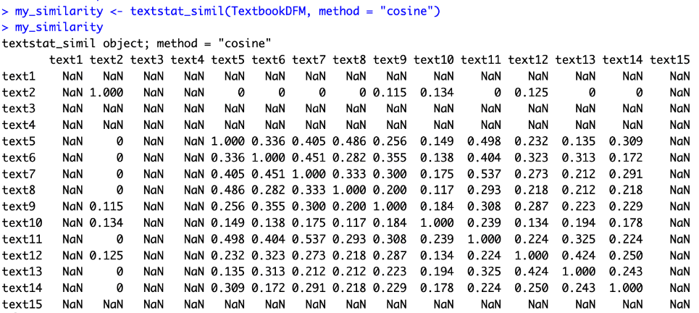

Figure 51

* textstat_summary() - provides summary statistics for a dfm, including word counts, feature frequencies, and text length measures.

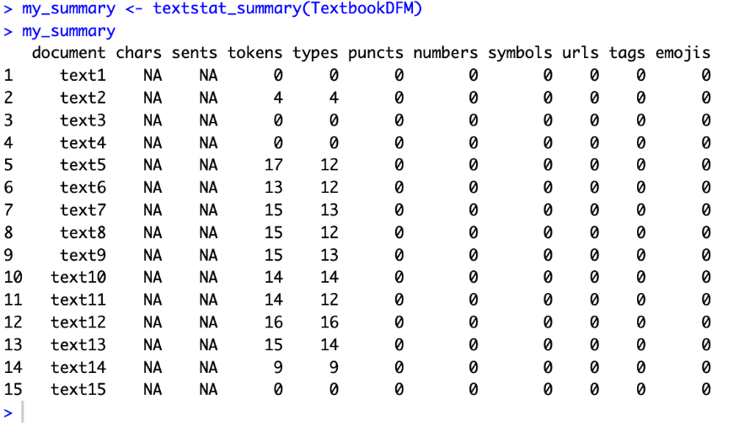

Figure 52

1. **Exploring syuzhet:**

* get_nrc_sentiment(): This function returns the sentiment of a given text based on the NRC lexicon as a data frame with columns for each sentiment category.

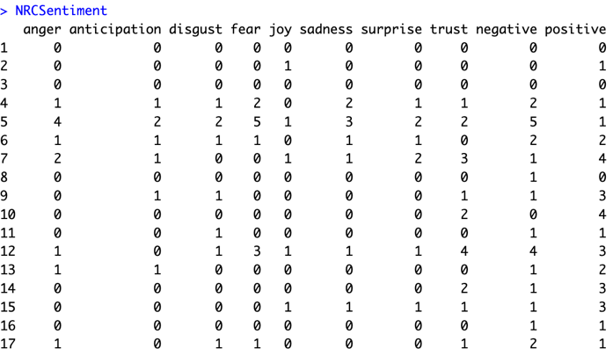

Figure 53

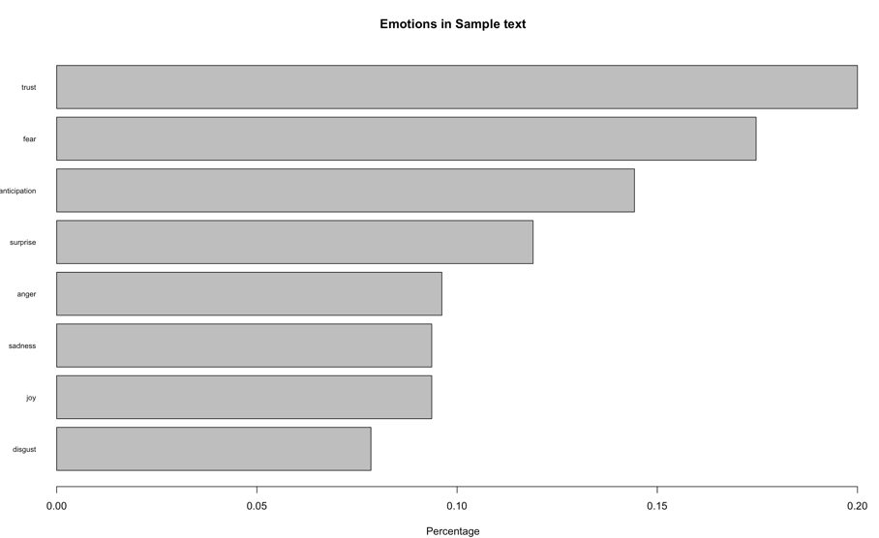

Figure 54

* get_transformed_values: Shape smoothing and normalization using a Fourier based transformation and low pass filtering is achieved using the get_transformed_values function.

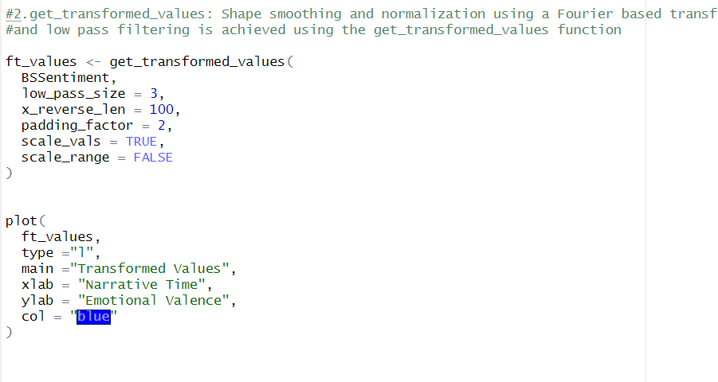

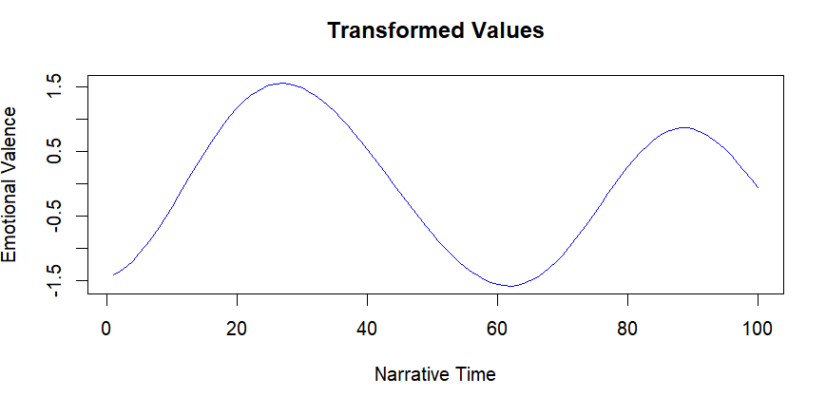

Figure 55

get_dct_transform: similar to get_transformed_values function, but it applies the simpler discrete cosine transformation (DCT).

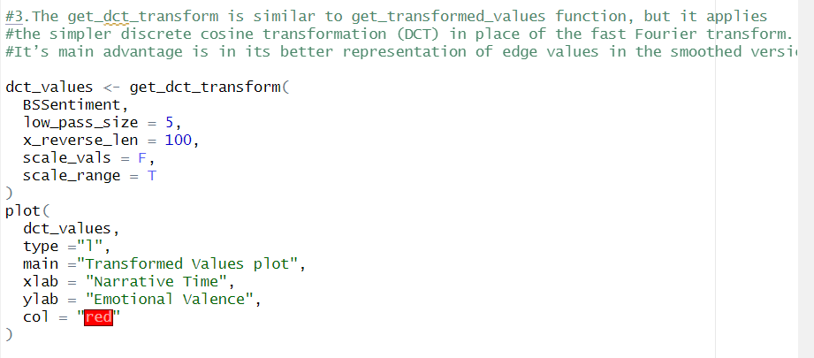

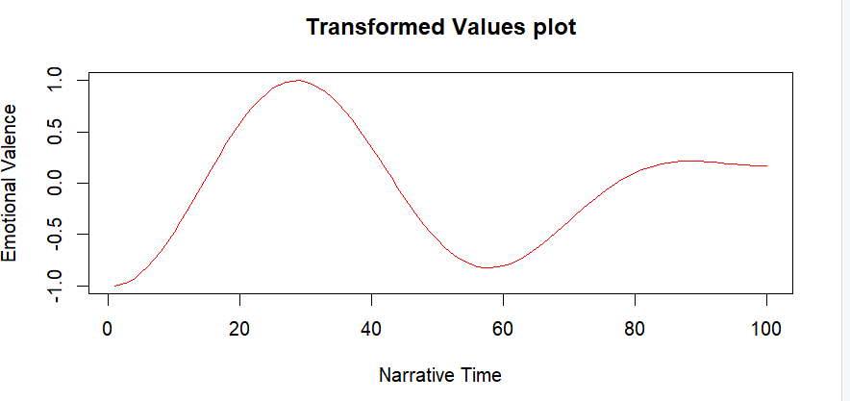

Figure 56

1. **Exploring TM package:**

* removeSparseTerms() is a function that removes terms from a term-document matrix that occur in fewer than a certain proportion of documents.

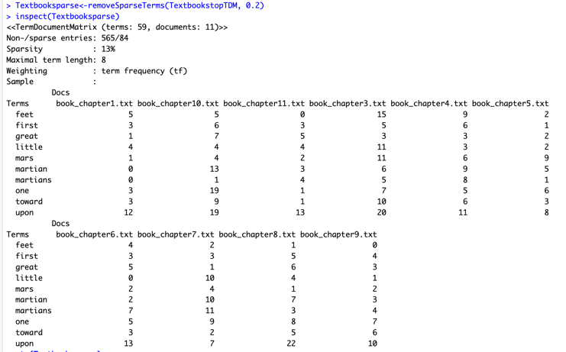

Figure 57

* dictionary: function in DTM which is used to specify custom dictionary of terms to be used for creation of DTM.

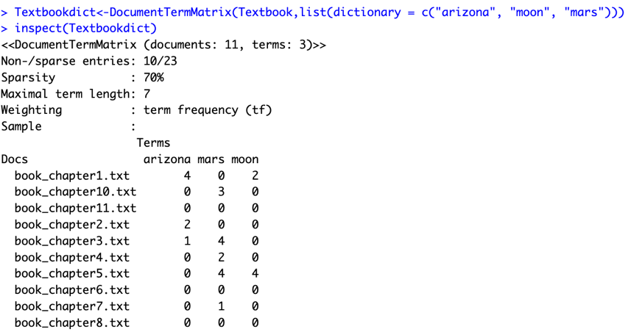

Figure 58

* Stemming of the document: it involves removal of prefixes and suffixes of the words so that the variation of the same word is treated as the same word. Through this, the number of words in our document increased significantly, hence giving us better data for our analysis.

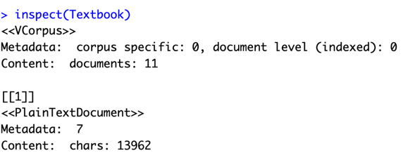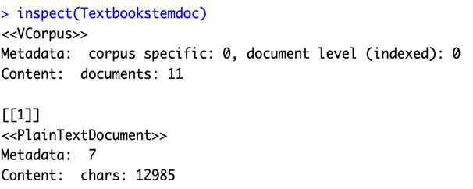

Figure 60

Figure 59

If we compare Figure 59 which represents the number of characters after stemming with Figure 60 which is our original document, we can see that there has been good amount of reduction in characters. Hence the stemming implementation was successful.

* 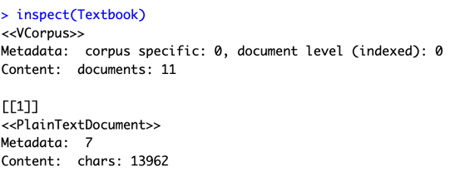stripWhitespace(): Removes leading and trailing whitespace from text document.

Figure 62

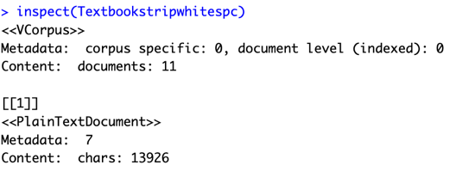

Figure 61

Comparing Figure 61 and 62, we can see that there is reduction of in the number of characters indicating the removal of whitespaces.

1. **Exploring WordCloud package:**

* Scaling the size of the words by a factor of 3.



Figure 63

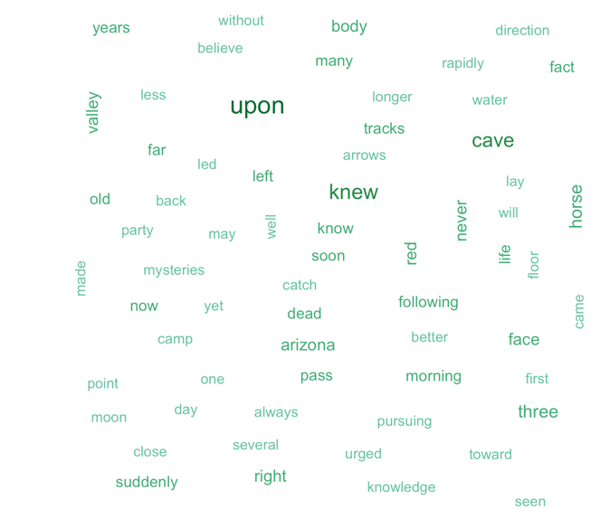

Figure 64

* Including words that appear only 10 times





Figure 65

Figure 66

* Including maximum of 50 words.

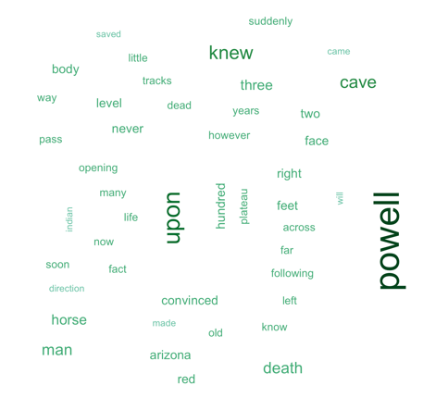

Figure 67



Figure 68

* Randomly ordering the words in the cloud.

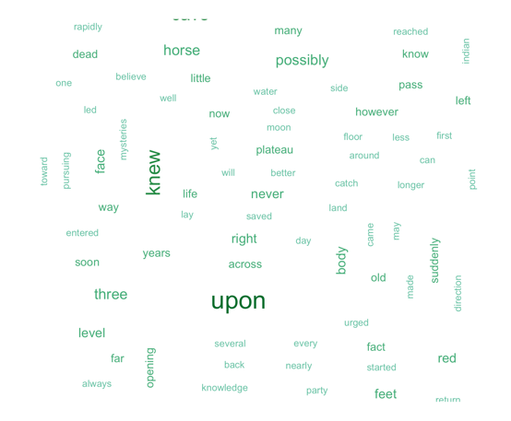

Figure 69



Figure 70

**Discussion and learnings of the project:**

This project has provided an insightful exploration of the various components of text analytics and how they can be applied to extract valuable insights from unstructured textual data. By implementing text pre-processing techniques, creating term-document matrices, and utilizing clustering methods, this project has highlighted the critical role that text analytics plays in uncovering hidden patterns and relationships within data. one of the most fundamental components of text analytics is data exploration, which involves preparing and cleansing textual data for subsequent analysis. This project has demonstrated how text tokenization, stop word removal, and text conversion to lowercase are essential first steps in text pre-processing. Additionally, identifying the longest words and sentences in each chapter has helped to illustrate the importance of feature extraction and its contribution to uncovering unique text attributes.

The methods used in the project included text pre-processing techniques such as tokenization, stop word removal, and text conversion to lowercase, as well as the creation of term-document matrices and clustering analysis. The results of the analysis provided insights into the key themes and topics present in the book. The most frequent words and phrases in the book were identified, and the clustering analysis helped to group similar words and phrases together, indicating potential relationships and patterns within the text.

Another vital aspect of this project is the construction of term-document and document-term matrices, which facilitates the systematic representation of text data in a structured form. This structured representation makes it more amenable to quantitative analysis, allowing for the application of statistical and machine learning techniques to identify patterns and relationships within the data. We also learned about the importance of TF-IDF vectors and learned about the frequency of the words utilizing the concepts of word cloud. We were able to perform quantitative analysis on an unstructured data and realized the importance of context in any text. Different kinds of semantic analyses were done like document category and word cloud. We could see that using various NLP functions we can analyze unstructured data and gain much information through the text. This project has substantially improved our understanding of text analytics by leading us through multiple stages of data exploration, pre-processing, and analysis. Through hands-on application, we have acquired essential insights into the capabilities of text analytics in discovering patterns and relationships within unstructured data. Furthermore, the project has emphasized the need to adopt a systematic and iterative approach to text analysis, which is vital for extracting meaningful insights from intricate textual data.